The EYFS framework is structured differently to the national curriculum as it is organised across seven Areas of Learning rather than subject areas. Although the ‘Technology’ strand has been removed from the EYFS Framework, many statements from the Early Learning Goals and Development Matters are prerequisites for computing within the national curriculum.

This table below outlines the most relevant statements from the following Areas of Learning for Reception to match the programme of study for computing:
• Personal, Social and Emotional Development
• Physical Development
• Mathematics
• Understanding the World
• Expressive Arts and Design

Personal, Social and Emotional Development | -show resilience and perseverance in the face of a challenge  -know and talk about the different factors that support their overall health and wellbeing ie sensible amounts of screentime
Physical Development | -develop their small motor skills so that they can use a range of tools competently, safely and confidently
Mathematics | -count objects, actions and sounds  -link the number symbol (numeral) with its cardinal number value  -select, rotate and manipulate shapes to develop spatial reasoning skills  -continue, copy and create repeating patterns
Expressive Arts and Design | -explore, use and refine and variety of artistic effects to express their ideas and feelings
Understanding the World | -explore how things work

At Ingol, we understand that computing and technology in Reception are vital in order for our children to start Year 1 with strong subject knowledge. However, computing does not necessarily mean typing out Word documents or creating code. Our computing scheme is centred around play-based, unplugged activities which focus on building children’s listening skills, curiosity, creativity and problem solving.

Computing in Reception can mean:
- taking a photograph with a camera or tablet
- searching for information on the internet
- playing games on the interactive whiteboard
- exploring mechanical toys/objects
- using a Beebot
- watching video clips
- listening to music

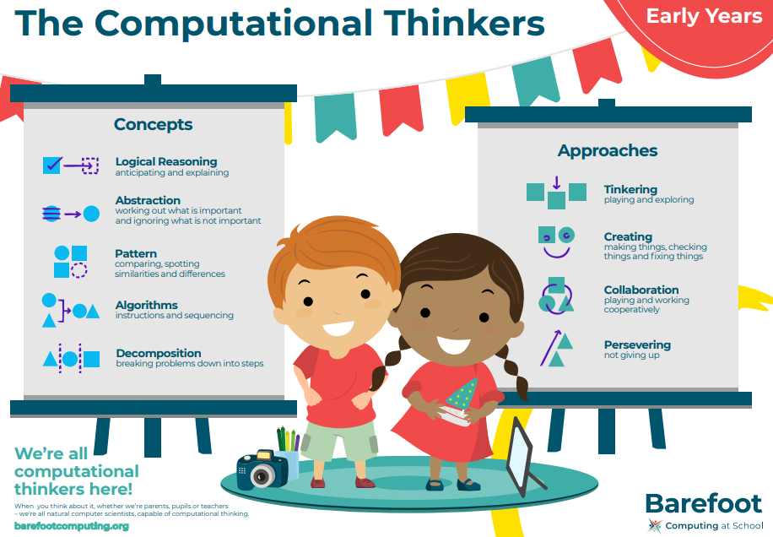
At Ingol, we are supported by the National Centre for Computing Excellence (NCCE) and deliver the Teach Computing curriculum in KS1 and KS2 recommended by them. For children in Reception, the NCCE recommend we follow Barefoot Computing which provide cross-curricular resources and activities based around computational thinking concepts and approaches.
We believe that allowing children the opportunity to explore technology in a child-led way leads to familiarity with equipment and vocabulary to enable a strong start in KS1.

Computing in Reception is largely cross-curricular with links to communication and language, mathematics, physical development and the characteristics of effective learning. Therefore, we use observations to gather evidence for the relevant Early Learning Goals for each area of learning.

