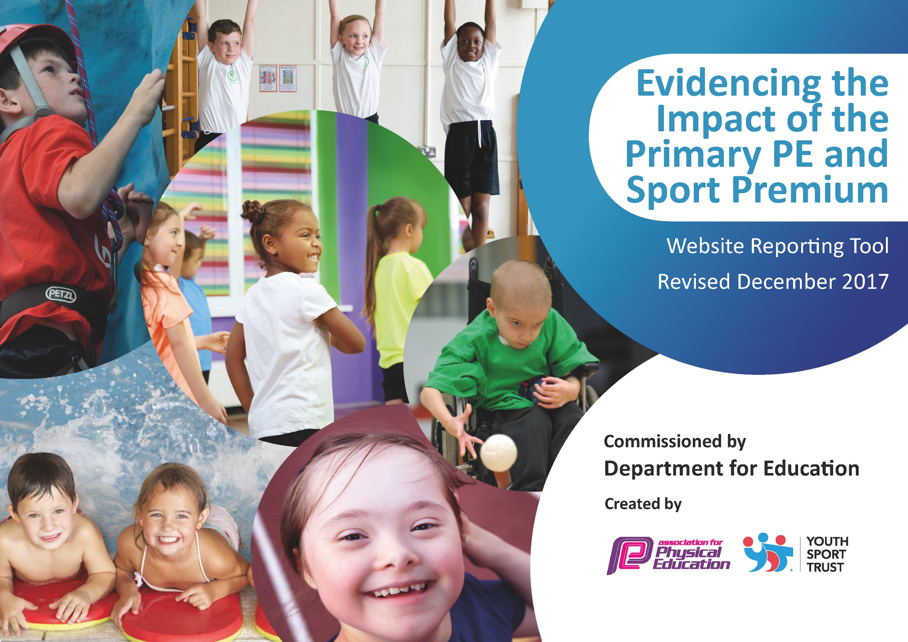

Schools must use the funding to make additional and sustainable improvements to the quality of PE and sport they offer. This means that you should use the Primary PE and Sport Premium to:

- develop or add to the PE and sport activities that your school already offers
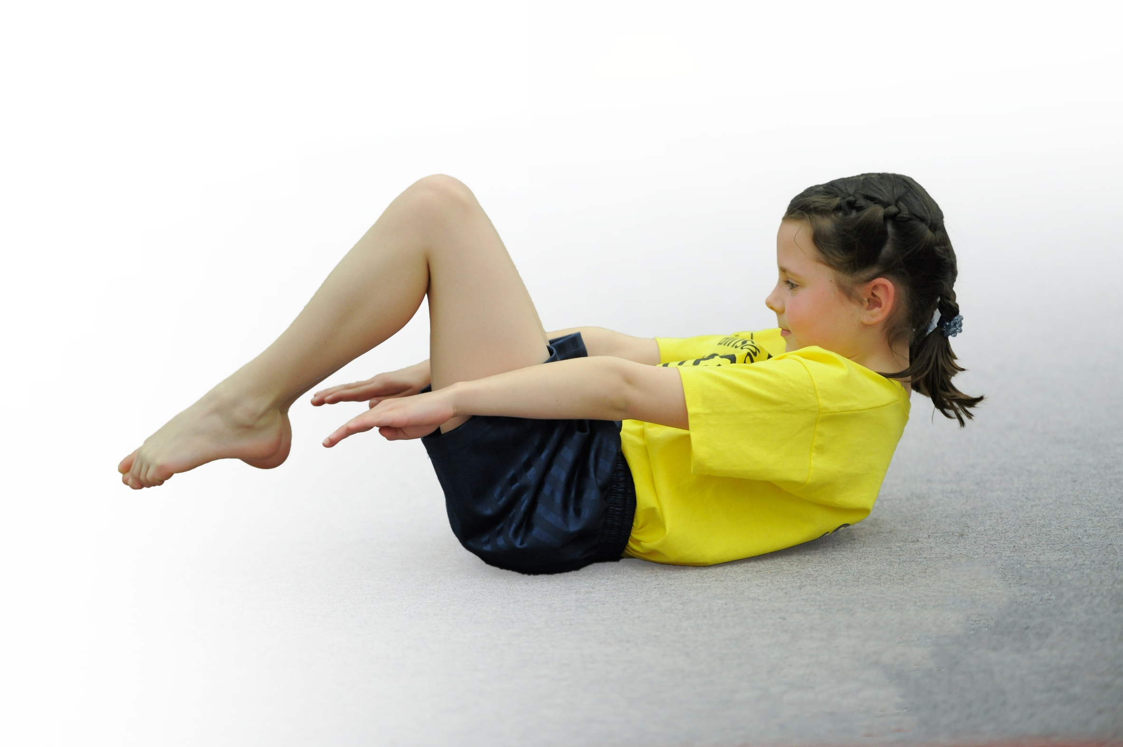
- build capacity and capability within the school to ensure that improvements made now will benefit pupils joining the school in future years

Please visit gov.uk for the revised DfE guidance including the 5 key indicators across which schools should demonstrate an improvement. This document will help you to review your provision and to report your spend. DfE encourages schools to use this template as an effective way of meeting the reporting requirements of the Primary PE and Sport Premium.

We recommend you start by reflecting on the impact of current provision and reviewing the previous spend.
Under the Ofsted Schools Inspection Framework, inspectors will assess how effectively leaders use
the Primary PE and Sport Premium and measure its impact on outcomes for pupils, and how effectively governors hold them to account
for this.

Schools are required to publish details of how they spend this funding as well as on the impact it has on pupils’ PE
and sport participation and attainment.
We recommend regularly updating the table and
publishing it on your website as evidence
of your ongoing review into how you are using the money
to secure maximum, sustainable impact. To see an example of how to complete the table please click HERE.

Support for review and reflection - considering the 5 key indicators from DfE, what development needs are a priority for your setting and your students now and why? Use the space below to reflect on previous spend, identify current need and priorities for the future.

Key achievements to date: | Areas for further improvement and baseline evidence of need:
To continue to enter competitions against other schools to broaden experiences of a range of sports for pupils  80% of children leaving KS2 could meet NC requirements due to using PE Premium to top up cost of swimming lessons  Gymnastics= Ks1, LKS2 and UKS2 competitions entered successfully. | Further continue to develop staff CPD and excellence and enjoyment of PE by utilizing skills of specialist sports coaches and staff expertise including Cricket and Rugby  Further Develop Gymnastics through signing up for more competitions  Apply for School Games Mark

Meeting national curriculum requirements for swimming and water safety | Please complete all of the below*:
What percentage of your current Year 6 cohort swim competently, confidently and proficiently over a distance of at least 25 metres?
What percentage of your current Year 6 cohort use a range of strokes effectively [for example, front crawl, backstroke and breaststroke]?
What percentage of your current Year 6 cohort perform safe self-rescue in different water-based situations?
Schools can choose to use the Primary PE and Sport Premium to provide additional provision for swimming but this must be for activity over and above the national curriculum requirements. Have you used it in this way?
*Schools may wish to provide this information in April, just before the publication deadline.

Action Plan and Budget Tracking
Capture your intended annual spend against the 5 key indicators. Clarify the success criteria and evidence of impact that you intend to measure to evaluate for students today and for the future.

Academic Year: 2023/24 | Total fund allocated:£17,430.00 | Date Updated: June 23
Key indicator 1: The engagement of all pupils in regular physical activity – Chief Medical Officer guidelines recommend that primary school children undertake at least 30 minutes of physical activity a day in school

School focus with clarity on intended impact on pupils: | Actions to achieve: | Funding allocated: | Evidence and impact: | Sustainability and suggested next steps:
Children given the opportunity to participate in the inter competitions at lunchtime. Use funds to maintain the new muga area, | PE lead to monitor the level of participation throughout school. | .  £2500
Key indicator 2: The profile of PE and sport being raised across the school as a tool for whole school improvement
School focus with clarity on intended impact on pupils: | Actions to achieve: | Funding allocated: | Evidence and impact: | Sustainability and suggested next steps:
Professional coaches employed to provide both in house sessions and after school clubs. Staff CPD ongoing with the coaches. | PE lead to monitor staffs competency and confidence through entry and exit questionnaires | £140.00

Key indicator 3: Increased confidence, knowledge and skills of all staff in teaching PE and sport
School focus with clarity on intended  impact on pupils: | Actions to achieve: | Funding  allocated: | Evidence and impact: | Sustainability and suggested  next steps:
Professional coaches employed to provide both in house sessions and after school clubs. Staff CPD ongoing with the coaches. Dance to be the main focus in spring term as this has been identified as a weaker area in delivery by teachers. | PE lead to monitor staffs competency and confidence through entry and exit questionnaires | £14,000
Key indicator 4: Broader experience of a range of sports and activities offered to all pupils
School focus with clarity on intended  impact on pupils: | Actions to achieve: | Funding  allocated: | Evidence and impact: | Sustainability and suggested  next steps:
Additional achievements:  More involvement with competitive sports with other schools. | Enroll school team in various competitions and offer a wider range of after school sports activities to cater for all abilities.  Explore the use of the more unusual sports.  Engage in the Preston School Partnership by attending meetings. | 200.00
Key indicator 5: Increased participation in competitive sport
School focus with clarity on intended  impact on pupils: | Actions to achieve: | Funding  allocated: | Evidence and impact: | Sustainability and suggested  next steps:
The school has entered more competitive competitions and is now entering two teams at some events.  PPESSA enrolment for the school | Enter A and B teams and ensure travel costs are met through PE premium funding | £15.00 per event  £150 per year

.

