Science Policy

Policy date: Sept 25

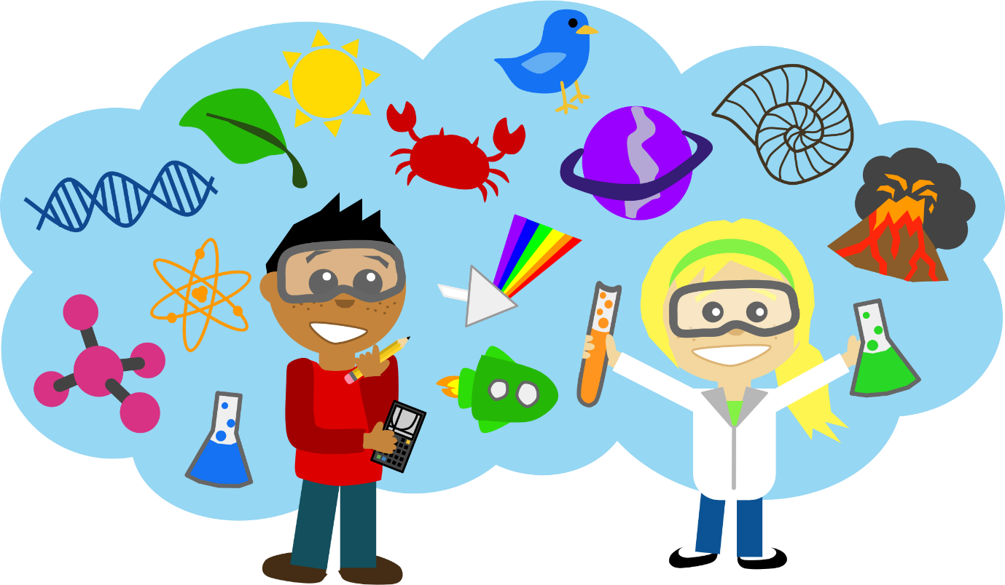
Intent
This policy outlines the teaching, organisation and management of science taught and learnt at Ingol Community Primary School. The school’s policy for science is based on the 2014 Curriculum for Key Stages 1 and 2. The policy has been drawn up to reflect the whole school approach to science and has been discussed with staff. The implementation of this policy is the responsibility of teaching staff.

Science teaches an understanding of natural phenomena. It aims to stimulate a child’s curiosity in finding out why things happen in the way they do. It teaches methods of enquiry and investigation to stimulate creative thought and independence. Children learn to ask scientific questions and begin to appreciate the way science will affect their future on a personal, national, and global level.
We believe that a broad and balanced science education is the entitlement of all children, regardless of ethnic origin, gender, class, aptitude or disability. Our aims in teaching science include the following:

- Ask and answer scientific questions;
- Plan and carry out scientific investigations, using equipment, including computers, correctly and independently;
- Know and understand the life processes of living things;
- Know and understand the physical processes of materials, electricity, light, sound and natural forces;
- Know about the nature of the solar system, including the earth;
- Evaluate evidence and present their conclusions clearly and accurately.

Teaching and Learning of Science
We use a variety of teaching and learning styles in science lessons. Our intent is to develop children’s knowledge, skills and understanding. Teachers engage the children in enquiry-based, practical lessons and encourage the children to ask, as well as answer, scientific questions. Teachers encourage children to be independent learners in Science and make their own choices, some of the time. They also use ICT in science lessons where appropriate. Wherever possible, we involve the pupils in ‘real’ scientific activities, for example, researching a local environmental problem or carrying out a practical experiment and analysing and presenting results.

Planning
Our school follows the programme of study outlined in the Curriculum 2014. We carry out our curriculum planning in science in two phases (long-term and short-term). The long-term plan maps the scientific topics studied in each term during the key stage. The science subject leader works this out in conjunction with teaching colleagues in each year group. In some cases we combine the scientific study with work in other subject areas. The class teacher is responsible for writing the short-term plans. Short-term plans should include the knowledge and understanding, working scientifically skills and the vocabulary that will be used in that unit of work. On these plans should also be the science principles of our school which should be highlighted in the lessons when they are being covered. These plans list the specific learning objectives, activities and outcomes for each lesson which will be differentiated where needed. Teachers ensure that there are opportunities for children of all abilities to develop their skills and knowledge in each unit and we also build progression into the science scheme of work, so that the children are increasingly challenged as they move up through the school. Our science planning is supported by Inspiring Science – Lancashire scheme of work.

Early Years Foundation Stage
We teach scientific skills in the reception class as in integral part of the topic work covered during the year. We relate the scientific aspects of the children’s work to the objectives set out in the Early Years Outcomes. Science makes a significant contribution to achieving the Early Years Outcomes and understanding of the world, e.g. through investigating what floats and what sinks when placed in water.

Pupils Premium
All staff know which pupils meet this criteria in their own class. Support staff are utilised to ensure that these pupils have the support they need to make good progress – this may be in a group of pupils with SEN, in a group of low achievers or in a group of very able pupils.

Inclusion
We aim to provide for all children so that they achieve as highly as they can in Science according to their individual ability. We will identify which pupils or groups of pupils are underachieving and take steps to improve their attainment. Gifted children will be identified and suitable learning challenges provided.

Equal Opportunities
Our school has ambitions for every child, whatever their background or circumstances. Children learn and thrive when they are healthy, safe and engaged. In order to engage all children: cultural diversity, home languages, gender and religious beliefs are all celebrated. Our curriculum includes a wide range of texts and other resources which represent the diversity and backgrounds of all our children.

Assessment
We assess children’s work in science by making teacher judgments as we observe them during each science lesson. At the end of a topic or a term the class teacher assesses the children against the Science KLIPS and records in the agreed assessment system. It is the class teacher’s responsibility to complete assessments for each unit. This assessment will include the children’s subject knowledge and understanding and working scientifically skills in Science.
Reports to parents on the attainment of their children are made termly and an end of year report is given to the child’s parent in the summer term. Reporting in science focuses on each child’s:-
- Attitude towards science;
- Progress on their knowledge and understanding of Science;
- Strengths and weaknesses when working scientifically in Science.

Resources
General resources are stored in a cupboard in a central location, topic specific resources are stored in classrooms and a list is available in the science store cupboard. Equipment is audited by the Science leader at the beginning and end of the year. It is a class teacher’s responsibility to speak to the Science leader regarding broken resources or lack of resources.

Ruth Goulding
Science Coordinator

July 2025

