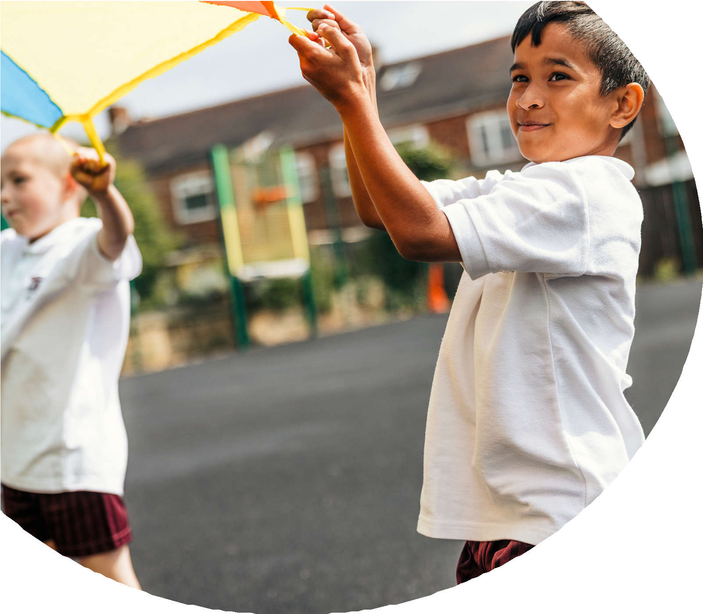
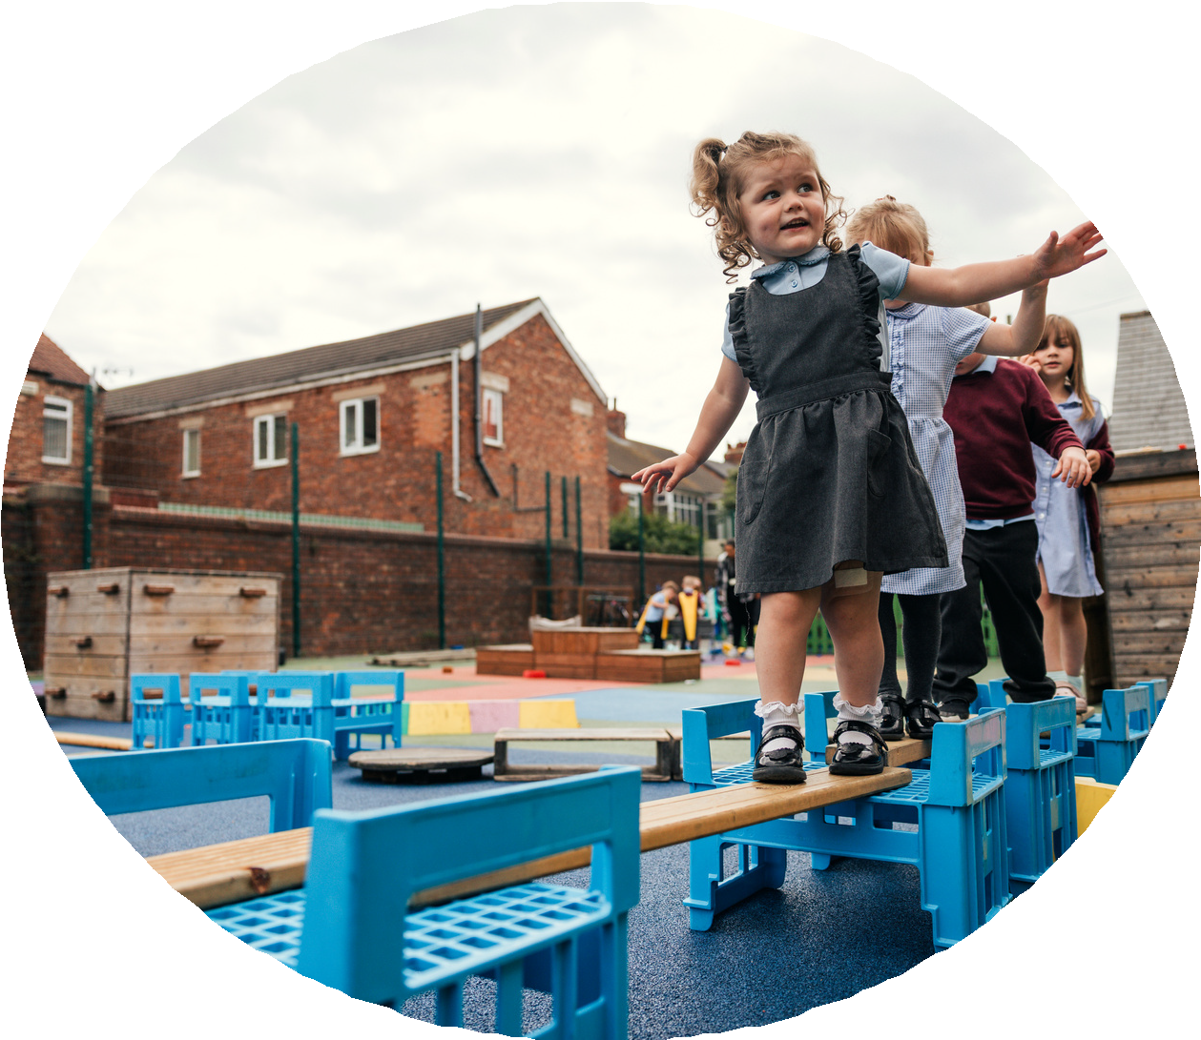

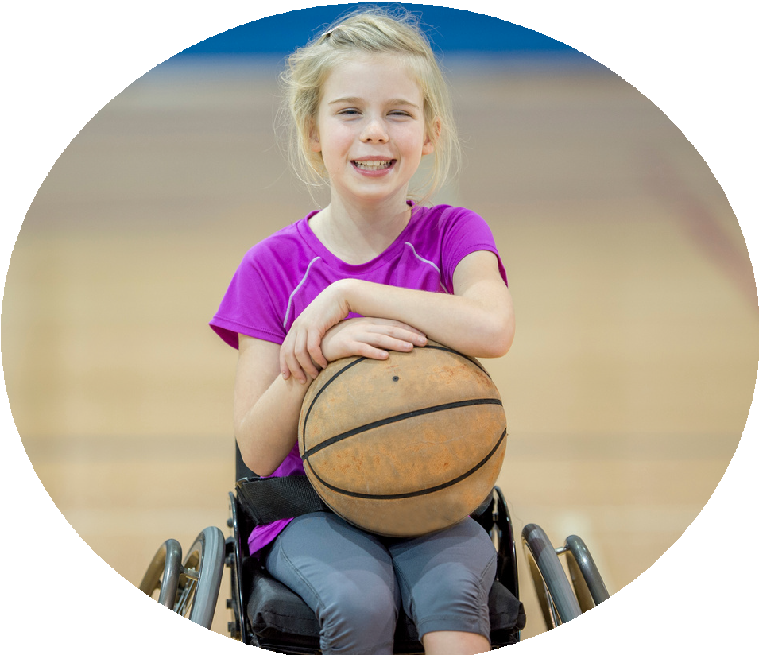



PE and sport premium monitoring and tracking form 2025/2026

Commissioned by

Created by


PE and sport premium monitoring and tracking form
- It is intended that this template should be used as preparation for the completion of the statutory DfE PE and sport premium digital expenditure reporting return. You can upload data (including swimming) from this template onto this platform once it becomes accessible.
- The template is a working document that you can amend and update during the year.
- Before you decide how you are going to use the funding for this academic year you should reflect and evaluate the impact of your use of you PE and sport premium funding in 2024/25.
- You should use your evaluation of last year’s funding to help you decide what to do this academic year, how you will do it, and what impact you expect it to have.
- All spending of the funding must conform with the terms outlined in the conditions of grant
- The summative digital expenditure reporting from June 2026 will continue to include swimming and water safety information. PE and sport premium funding can be used to provide top-up lessons, where necessary, to ensure pupils meet national curriculum swimming requirements
- To ensure funding is used effectively and based on your school’s needs; guidance and examples of best practice across schools can be found here.
- You must use the funding to make additional and sustainable improvements to the PE and sport in your school.
- You must develop and add to the PESSPA activities that your school already offers.

Useful Links:
- PE and sport premium for primary schools - GOV.UK
- PE and sport premium: conditions of grant 2025 to 2026 - GOV.UK
- It is intended that this template should be used as preparation for the completion of the statutory DfE PE and sport premium digital expenditure reporting return. You can upload data (including swimming) from this template onto this platform once it becomes accessible.
- The template is a working document that you can amend and update during the year.
- Before you decide how you are going to use the funding for this academic year you should reflect and evaluate the impact of your use of you PE and sport premium funding in 2024/25.
- You should use your evaluation of last year’s funding to help you decide what to do this academic year, how you will do it, and what impact you expect it to have.
- All spending of the funding must conform with the terms outlined in the conditions of grant
- The summative digital expenditure reporting from June 2026 will continue to include swimming and water safety information. PE and sport premium funding can be used to provide top-up lessons, where necessary, to ensure pupils meet national curriculum swimming requirements
- To ensure funding is used effectively and based on your school’s needs; guidance and examples of best practice across schools can be found here.
- You must use the funding to make additional and sustainable improvements to the PE and sport in your school.
- You must develop and add to the PESSPA activities that your school already offers.

Useful Links:
Complete the PE and sport premium expenditure reporting return - GOV.UK
PE and sport premium for primary schools - GOV.UK
PE and sport premium: conditions of grant 2024 to 2025 - GOV.UK

Review of the last academic year (2024/2025)

Swimming and Water Safety | What went well? Supporting evidence? | What didn't go well? Supporting evidence?
1. Swim competently, confidently and proficiently over a distance of at least 25 metres | 80% passed | We needed to commission additional sessions to get to this figure as the majority of our children do not go swimming outside of these school lessons.
2. Use a range of strokes effectively (for example, front crawl, backstroke and breaststroke) | 80% passed
3. Perform safe self-rescue in different water-based situations | 80% passed
- Take some time to reflect on your intent, implementation and impact from last academic year to celebrate your wins but to also think about improvements for the year ahead.
- You do not need to complete every box. Just record the information that is key to your school's priorities and areas of focus.
Remember - Be clear about how you focussed spending on key groups such as SEND, girls and disadvantaged pupils.

Review of the last academic year (2024/2025)
Key areas as outlined in PE and sport premium guidance | What went well? Supporting evidence? | What didn't go well? Supporting evidence?
1. Increasing confidence, knowledge and skills of all staff in teaching PE and sporting activities prioritising CPD and training where needed | After CPD, staff have developed a new confidence in teaching gymnastics. | If staff are absent, supply staff don’t have the same knowledge and understanding so we need to swap staff to teach this effectively.
2. Increasing engagement of all pupils in regular physical activity and sporting activities | More pupils meeting their daily physical activity goal, more pupils encouraged to take part in PE and Sport Activities | Not all children want to participate in additional sports so we have used the track to incorporate daily mile.
3. Raising the profile of PE and sport across the school, to support whole school improvement | The use of ex professionals to support our curriculum delivery inspired children to work hard to achieve their ambition. The CPD they will provide for teachers will be sustainable.  More children attended the cricket after school club and went to Old Trafford to watch a match. | It does cost to get these professionals in to school.
4. Offer a broader and more equal experience of a range of sports and physical activities to all pupils and ensure equal access to sport for boys and girls | Using coaching staff who are trained to deliver different sports to increase our offer worked well. | The cost of this could be a barrier in the future.
5. Increasing participation in competitive sport | We have joined a league which has seen an increase in % of children taking part in competitive sports and we will join again next year. | Again, some children can’t participate in after school sports as families can’t always collect at the times needed.

Aims for the next academic year (2025/2026)
- Using your whole school priorities, school development plan and previous PE, school sport and physical activity data, set out your aims for the year ahead.
- Think about specific areas of need such as inactive girls, SEND and disadvantaged pupils
- Remember to also input your swimming data and reflections in the table located at the bottom of this page.
- Consider which of the 5 key areas improvements will be focussing on:
- Increasing confidence, knowledge and skills of all staff in teaching PE and sporting activities prioritising CPD and training where needed.
- Increasing engagement of all pupils in regular physical activity and sporting activities
- Raising the profile of PE and sport across the school, to support whole school improvement
- Offer a broader and more equal experience of a range of sports and physical activities to all pupils and ensure equal access to sport for boys and girls
- Increasing participation in competitive sport
Swimming and Water Safety | Input data | Reflections
1. Swim competently, confidently and proficiently over a distance
of at least 25 metres
2. Use a range of strokes effectively
(for example, front crawl, backstroke and breaststroke)
3. Perform safe self-rescue in different water-based situations

Aim | Why? | Key area | Supporting evidence
1. Increase Physical Activity Across the School Day  Objective: Ensure all pupils engage in at least 60 minutes of physical activity daily. | The engagement of all pupils in regular physical activity – the Chief Medical Officer guidelines recommend that all children and young people aged 5 to 18 engage in at least 60 minutes of physical activity per day, of which 30 minutes should be in school in addition to PE. | Increase Physical Activity Across the School Day
Enhance staff confidence and competence in delivering high-quality PE | To provide quality first teaching across the range of genres. | 2. Improve the Quality of PE Teaching
Increase pupil engagement by offering diverse and inclusive activities. | Greater choice leads to higher participation. It also ensures that SEND pupils, girls and disadvantaged pupil have equal opportunitiy to participate as within the school offer. | 3. Broaden the Range of Sports and Activities Offered
Develop pupils’ teamwork, resilience, and sportsmanship through competition. | Developing teamwork, sportsmanship, and resilience through sport is vital for children's personal growth, social development, and long-term success—both in and out of school.  Schools that embed these values through sport are more likely to see improved behavior, attendance and wellbeing. | 4) Increase Participation in Competitive Sport
Celebrate achievements and embed PE into the wider school ethos. | Recognidsing efforts as wellas success builds self esteem and helps children to feel valued beyond the academic success. It encourages wider participation and therefore this brings additional benefits as mentioned above. | 5. Raise the Profile of PE and Sport Across the School
Aims for the next academic year (2025/2026)

Plan, monitor and evaluate (2025/2026)
- Please aim to use this as a live working document through the year.

- Keep returning to this to evidence adaptations and progress made through the PESSPA opportunities you provide.

- There is no set number of objectives you must have.

- Make as many or as few as you see fit that will support your aims for the year ahead.

- Consider which of the 5 key areas improvements will be focussing on:
- Increasing confidence, knowledge and skills of all staff in teaching PE and sporting activities prioritising CPD and training where needed.
- Increasing engagement of all pupils in regular physical activity and sporting activities
- Raising the profile of PE and sport across the school, to support whole school improvement
- Offer a broader and more equal experience of a range of sports and physical activities to all pupils and ensure equal access to sport for boys and girls
- Increasing participation in competitive sport

Plan, monitor and evaluate (2025/2026)

Example objective shown below is for reference purposes only:
 | Intent – what is your objective? | Implementation - How will you achieve this? | Impact - What do you hope to see? | Supporting evidence
Plan and monitor | Develop lunchtime play provision to increase activity for least active groups. | Develop pupil leadership (training programme), Midday supervisor training, Staff CDP to develop their understanding of games and play, Range of equipment, Youth voice activities to understand pupils wants and needs Outdoor play provision such as OPAL | A confident and competent group of activity leaders that take initiative and create a more active and inclusive playground for all pupils. Midday supervisors and all staff leading a range of physical activities and joining in with movement daily to role model. A happier, more active playground that meets the needs of all pupils especially SEND and girls. | Youth voice data through half-termly surveys and interviews/group discussions with a variety of pupils (leaders, children participating and those that are less active at break times). Conduct regular observations of the playground to gauge activity levels of the least active children. Staff voice and feedback
 | What impact have you seen? | Are the improvements sustainable? How? | Supporting evidence | Approx. cost
Evaluate | Activity leaders are leading a broad range of activities and actively seeking children that are not engaged in physical activity during lunch times. Midday supervisors have grown in confidence and far more active and engaged in games with the children. Lunch times are more active with children having fun. Activity options have been tailored to suit the needs of SEND pupils through considerate choices of equipment and the types of games played. Girls are proving to be the hardest group to engage as some are still choosing not to be active | Continued training for activity leaders and bringing new leaders into the group to bring new ideas and expertise. More leaders will also mean more activities are able to be delivered. Continued training with midday supervisors. Establish lead midday supervisors to empower them and give them ownership. Continue to listen to SEND pupils and tailor activities to their needs and wants. Focus priorities on engaging girls. Work with least active girls to create activities that are meaningful and enjoyable for them. Do they want to be activity leaders for younger children to give them purpose and confidence? | 100 out of 100 activity leaders want to carry on with this role next year. 30 more children have enquired to joining the team. Meetings and the end of year survey have shown all leaders feel positive and enjoy making a difference for others. Interviews by random selection were conducted and 92% of pupils were either 'happy' or 'very happy' with the activities on offer at lunch time. End of year physical activity survey findings such as:  - Am I involved with games at lunch time - 89% Yes  - Do I enjoy lunch time? 97% Yes  - Have I joined in with a game with the activity leaders? 100% Yes | Physical Resources - £1000  CPD for staff - £500  OPAL - £8000
Your Objective:

 | Intent – what is your objective? | Implementation - How will you achieve this? | Impact - What do you hope to see? | Supporting evidence
Plan and monitor | Objective: Ensure all pupils engage in at least 60 minutes of physical activity daily. | Introduce active breaktimes and lunchtime activities.  Implement active travel initiatives (e.g. walk/scoot to school weeks).  Embed movement into classroom learning (e.g. active maths/English). | ≥85% of pupils report achieving 60 minutes of activity daily (via pupil survey).  Reduction in sedentary behaviour observed during lesson observations.  Participation in active travel increases by 20% from baseline.
 | What impact have you seen? | Are the improvements sustainable? How? | Supporting evidence | Approx. cost
Evaluate

Your Objective:

 | Intent – what is your objective? | Implementation - How will you achieve this? | Impact - What do you hope to see? | Supporting evidence
Plan and monitor | Increase pupil engagement by offering diverse and inclusive activities. | Introduce new sports (e.g. yoga, archery, dance, boccia).  Run taster sessions and pupil-led clubs.  Ensure activities cater to SEND and less active pupils. | ≥75% of pupils participate in at least one new sport/activity.  SEND and disadvantaged pupil participation increases by 25%.  Pupil feedback shows ≥90% enjoyment in new activities.
 | What impact have you seen? | Are the improvements sustainable? How? | Supporting evidence | Approx. cost
Evaluate

Your Objective:
 | Intent – what is your objective? | Implementation - How will you achieve this? | Impact - What do you hope to see? | Supporting evidence
Plan and monitor | Develop pupils’ teamwork, resilience, and sportsmanship through competition. | Join local school sport partnerships and leagues.  Participate in intra-school competitions each term.  Provide transport and support for inter-school events. | An increased number of KS2 pupils participate in competitive sport.  School enters ≥6 inter-school competitions annually.  Positive pupil feedback on teamwork and confidence (≥85%)
 | What impact have you seen? | Are the improvements sustainable? How? | Supporting evidence | Approx. cost
Evaluate

Your Objective:
 | Intent – what is your objective? | Implementation - How will you achieve this? | Impact - What do you hope to see? | Supporting evidence
Plan and monitor | Celebrate achievements and embed PE into the wider school ethos | Create a PE and Sport display board and newsletter section.  Celebrate sporting achievements in assemblies.  Link PE to wellbeing and academic outcomes | PE and sport featured in ≥2 newsletters per term.  ≥90% of pupils feel proud of their sporting achievements.  Staff report improved pupil focus and wellbeing linked to activity
 | What impact have you seen? | Are the improvements sustainable? How? | Supporting evidence | Approx. cost
Evaluate

Your Objective:

 | Intent – what is your objective? | Implementation - How will you achieve this? | Impact - What do you hope to see? | Supporting evidence
Plan and monitor | Enhance staff confidence and competence in delivering high-quality PE | Use PE assessment tools to track pupil progress.  Review and update PE curriculum to ensure progression and variety. | ≥90% of PE lessons rated “good or better” in internal monitoring.  Pupil attainment in PE improves by 15% based on assessment data.
 | What impact have you seen? | Are the improvements sustainable? How? | Supporting evidence | Approx. cost
Evaluate

This page has been left blank for any notes or supporting information.

