Ingol Community Primary School – Book coverage for English 
 | Autumn 1 | Autumn 2 | Spring 1 | Spring 2 | Summer 1 | Summer 2
 | All About Me | Superheroes  Time to Celebrate | Frozen Planet | Traditional Tales | Animal Antics | Under the Sea
EYFS | 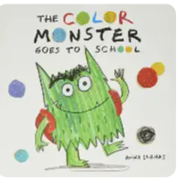  The Colour Monster Goes to School  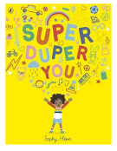  Super Duper You  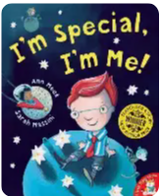  I’m Special, I’m Me  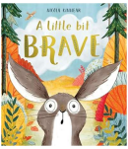  A Little Bit Brave  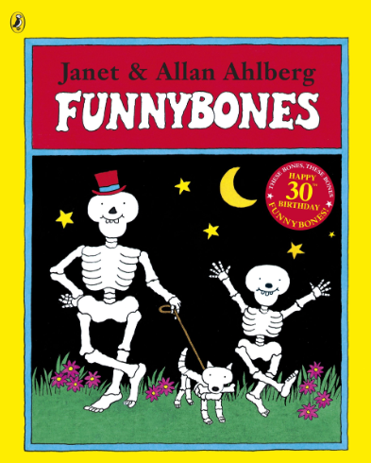  Funnybones  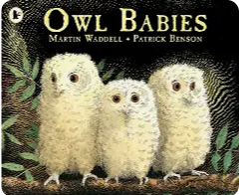  Owl Babies  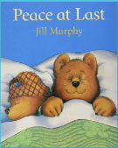  Peace at Last | 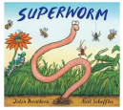  Superworm  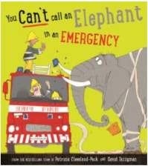  You Can’t call an Elephant in an Emergency  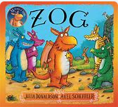  Zog  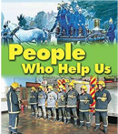  People Who Help Us  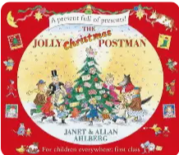  The Jolly Christmas Postman  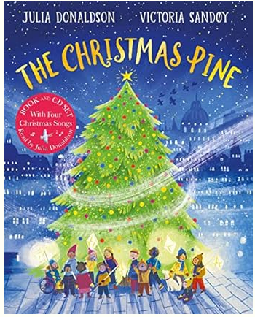  The Christmas Pine  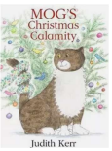  Mog’s Christmas Calamity | 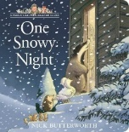  One Snowy Night  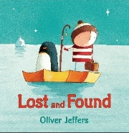  Lost and Found  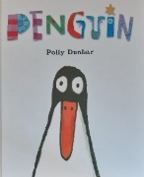  Penguin  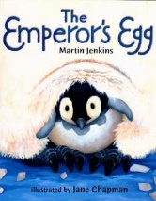  The Emperor’s Egg  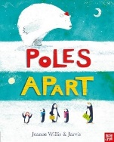  Poles Apart  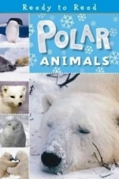  Polar Animals | 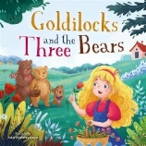  Goldilocks and The Three Bears  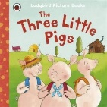  The Three Little Pigs  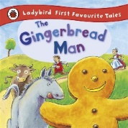The Gingerbread Man  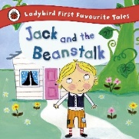  Jack and the Beanstalk  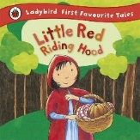  Little Red Riding Hood | 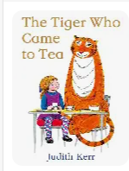  The Tiger Who Came to Tea  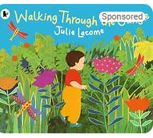  Walking Through the Jungle  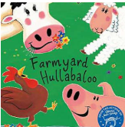  Farmyard Hullabaloo  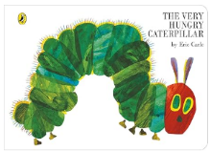  The Very Hungry Caterpillar  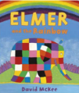  Elmer  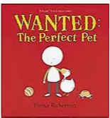  Wanted: The Perfect Pet | 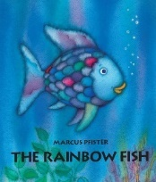  Rainbow Fish  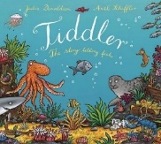  Tiddler  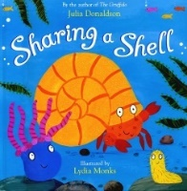  Sharing a Shell  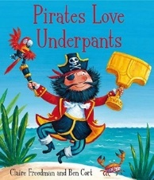  Pirates Love Underpants  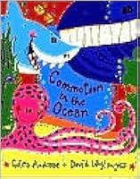  Commotion in the Ocean  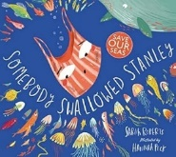  Somebody Swallowed Stanley

Year 1 | Autumn 1 | Autumn 2 | Spring 1 | Spring 2 | Summer 1 | Summer 2
Year 1 | 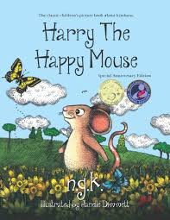  Harry the happy mouse  Story as a theme  Information posters | 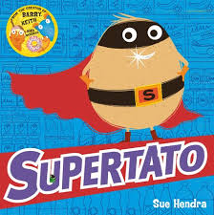  Supertato  Narrative  Poetry | 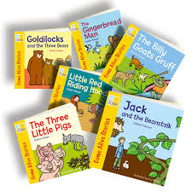  Traditional tales  Instructions | 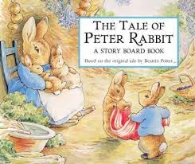  Peter rabbit  Novel as a theme  Non-chronological reports/fact files | 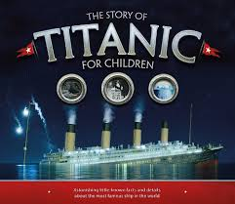  Titanic  Information booklet  Poems | 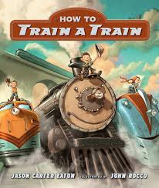  How to train your train  Novel as a theme  Instructions

Year 2 | Autumn 1 | Autumn 2 | Spring 1 | Spring 2 | Summer 1 | Summer 2
Year 2 | 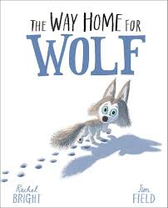  The way home for wolf  Narrative text  Information leaflet  Poetry on a theme | 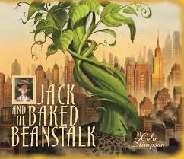  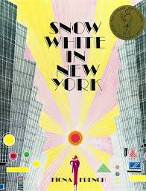  Jack and the baked beanstalk and Snow White in New York  Traditional tales with a twist  Instructions  Riddles | 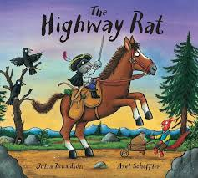  The Highway Rat  Narrative text  Poetry | 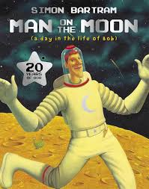  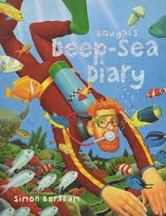  Man on the moon and Dougal’s deep-sea diary  Stories by the same author  Classic Poetry | 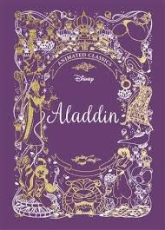  Aladdin  Narrative  Non-chronological reports  Poetry | 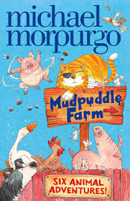  Mudpuddle farm  Narrative - Animal stories  Explanation texts

Year 3 | Autumn 1 | Autumn 2 | Spring 1 | Spring 2 | Summer 1 | Summer 2
Year 3 | 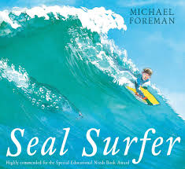  Seal surfer | 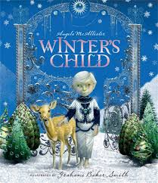  A winter’s child | 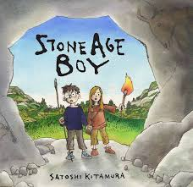  Stone Age boy | 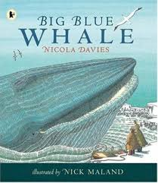  Big blue whale | 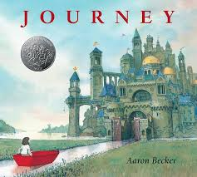  Journey | 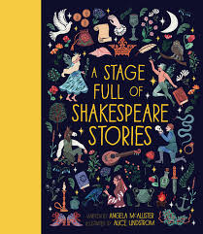  A stage full of Shakespeare stories

Year 4 | Autumn 1 | Autumn 2 | Spring 1 | Spring 2 | Summer 1 | Summer 2
Year 4 | 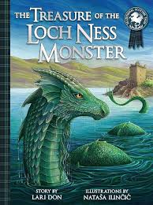  Novel as a theme  Magazine articles | 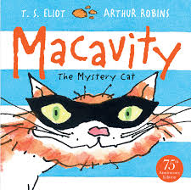  Poetry  Non-chronological reports  Play scripts | 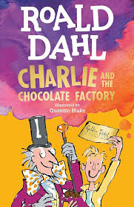  Novel as a theme  Persuasion | 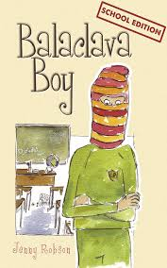  Issues and dilemmas  Explanation texts | 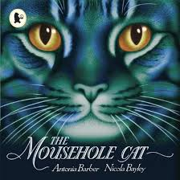  Stories on a theme  Kenning and haiku poems | 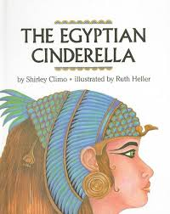  Fairy tales  Debates

Year 5 | Autumn 1 | Autumn 2 | Spring 1 | Spring 2 | Summer 1 | Summer 2
Year 5 | 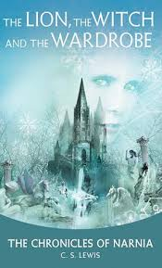  Lion the with and the wardrobe  Classic texts  Non-chronological reports | 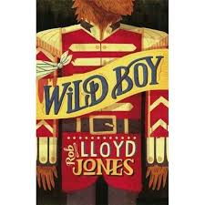  Wild boy  Stories with historical settings  Classic poetry  Films/playscripts | 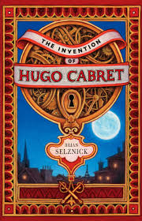  Hugo Cabret  Novel as a theme  Persuasion | 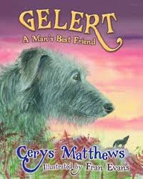  Gelert  Myths and Legends  Magazine information text hybrid | 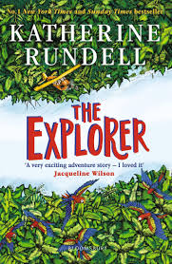  Explorer  Stories from other cultures  Debates | 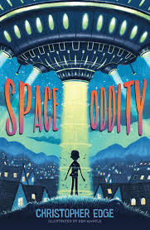  Space Oddity  Science Fiction texts  Information booklets

Year 6 | Autumn 1 | Autumn 2 | Spring 1 | Spring 2 | Summer 1 | Summer 2
Year 6 | 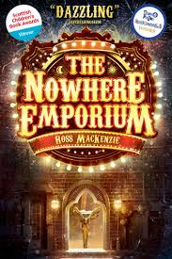  The nowhere emporium  Novel as a theme  Information text | 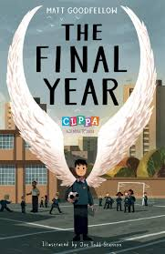  The final year  Explanations  Novel – poetry | 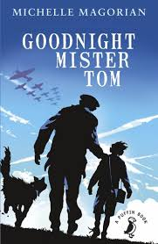  Goodnight Mr Tom  Classic fiction | 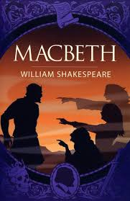  Macbeth  Older Literature | 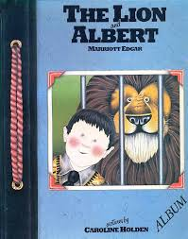  The Lion and Albert  Classic narrative poetry | 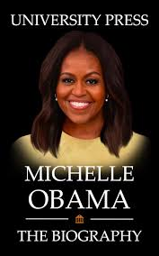  Michelle Obama  Biographies

