RE coverage across school
We use the Lancashire SACRE scheme of work for planning and assessment.
Autumn |  |  |  |  | Spring |  |  |  |  |  |  | Summer
General learning throughout the year
Pupils will explore key celebrations/festivals in Christianity, Islam and Hinduism.

EYFS
To know why some things are special to different people.

- To know about different celebrations.  - To understand why people celebrate special occasions. |  |  |  |  | - To know why some stories are special.  - To know what special messages we can learn from stories. |  |  |  |  |  |  | - To know about special places.  - To know what buildings and places are special to different people.
Key vocabulary

Celebration, special, occasion, respect, beliefs, buildings, Christmas, Easter, Diwali, Christianity, Islam, Hinduism.

Children respect special things in their own lives. | Children recognise that people have different beliefs and celebrate special times in different ways. Children recognise some environments that are different to the one in which they live. | Children understand what curiosity is and importance of asking questions. Children find out about other countries and people through non-fiction texts, stories, visitors, celebrations. | Children understand what curiosity is and importance of asking questions. Children find out about other countries and people through non-fiction texts, stories, visitors, celebrations including Easter. | Children can compare and contrast different places. Children show respect to one another and to animals. | Children know that different places are special to different people.

Year One
Christianity (God & Jesus) |  |  |  |  | Islam/Judaism |  |  |  |  |  |  | Hinduism/Christianity (Church)
- To know why Christians say God is a father.  - To know why Jesus is special to Christians |  |  |  |  | - To know that Muslims believe in one God ‘Allah’.  - To know why some people put their trust in God. |  |  |  |  |  |  | - To know that Hindus believe in God.  - How might some people show that they ‘belong’ to God?
Key Vocab
God  God the Father  Prayer  kindness, love, funny, generosity, magic, bible, forgiveness. | Jesus  Christmas Nativity family, presents, celebrate, love, care |  |  |  | Judaism  God’s promise, Noah, Abraham, trusting in God, Hanukka,, Star of David |  | Islam  Muslim, Allah, creator, natural word, environment, caretaker, creation |  |  | Christianity – church  Baptism, belonging, God the Father, family, symbols, belief |  |  |  |  |  | Hinduism  Roles, family, community, murtis, , shrine, Gods, Shiva, Vishnu and Brahma
Suggested tasks and clips
Christianity God  - talk about why Christians might compare God to a loving parent how and why Christians might want to talk to God  - Children to write a list to show how they can show their love for someone. Then put these sentences into a recipe for how to be a good parent.  - suggest symbolic meanings of rituals and items used in Christian prayer  - talk about the importance of love in families, talk about the ways in which they are cared for and supported by family members  - Chn to role play the story of the Lost Son and compare to their own lives  - reflect on their own role within the family, discuss who they can talk to when they are happy/sad/worried  - Write their own Lord’s prayer  - https://www.youtube.com/watch?v=bS5BFgQWRU4&index=27&list=PLcvEcrsF_9zJxDHG9Jtc CmiAgwVFRW3uK  Christianity Jesus  - Discuss why family is important and who is responsible for raising children in a family? How do people prepare for a new baby?  - Discuss the difference between gifts of financial value and gifts such as love and family and caring.  - Chn to split their book in half and draw pictures of both financial gifts such as toys and non financial such as love and care.  - Discuss, understand and sequence the nativity story. Why do Christians tell this story at Christmas and who were the important roles in the story. Why is this story important to tell.  - In books, children draw a picture of them or their family at Christmas and write how they celebrate Christmas around the outside  - Retelling the Nativity story.  - Ask questions to Rev Rie  - The Christian Story of the First Christmas – BBC Teach  - What is Christmas? – BBC Bitesize |  |  |  |  | Islam  - Pupils go for a nature walk and talk about aspects of nature that they enjoy. They collect leaves, acorns etc. and use these to make a collage in the outdoor area.  - Talk about their own experiences and feelings about the natural world and what they have noticed about the way that humans treat it  - Chn to sort out good v bad environment pictures  - Chn to think of questions to ask Mr Malyon about his job.  - https://www.youtube.com/watch?v=m5TwT69i1lU  - https://www.youtube.com/watch?v=_bN7KIMmwlc  - https://www.articlesoffaith.co.uk/faiths/islam.html?limit=all  Judaism  - Share a promise story with the class – eg ‘A promise is a Promise’ by Robert Munsch. Circle time – discuss the importance of promises. Ask the children to give examples of promises that they have made within the class. E.g. I promise I will not hit, I promise I’ll wait my turn  - Role play the story of Noah and the symbol of the rainbow as God’s promise never to send a flood to destroy the world again.  - They will investigate the festival of Sukkot as an annual reminder to the Jewish community to be thankful to God for all he has done.  - Design a sukkah and label diagram.  - Make their own sukkah  - Pupils will also have opportunities to talk about why promises and trust are an important aspect of human life.  - http://www.early-years.org/sesame-tree/activity-cards/activity-card.php?acn=14&acs=2  - https://www.youtube.com/watch?v=h_W1pGtlRsY |  |  |  |  |  |  | Hinduism  - Reflect on how other may see them.  - Talk about the different roles that they might have (friend, brother, child, sister etc.)  - Children to be given a paper person outline to create themselves. Children to write their name in the middle of the person and in a different colour write all their other names and roles they have around the outside.  - Listen to the story of the blind men and the elephant. Children to record what the blind men saw the elephant as.  - Research the three deities in Hinduism. Gather children within a circle and have a range of murtis to pass around and for children to explore.  - As small groups of 4 or 5, children use materials provided to make a Hindu shrine  - Investigate the use of a murti in Hindu worship  - Talk about how and why Hindus might use statues and images (murtis) in their worship.  Christianity (Church)  - know that Christians refer to God as ‘Father’  - talk about why Christians might compare God to a loving parent  - suggest symbolic meanings of rituals and items used in Christian prayer children draw pictures and then write matching labels of the key Christian symbols we learnt about.  - Draw a picture of a Christian church, underneath their picture, children write reasons why Christians might go to church  - Inside a church’ activity sheet, children label the different features inside the church.  - understand what a baptism is and how it shows children belong to a church  - Hold a baptism for a class doll/teddy. Create invitations for other members of the school community to attend. Work with the children to identify who and what they will need for the baptism.  - Design and make baptism certificates – what images, symbols or words could they use to show that the baby is now a member of the Christian family?  - Design and create a stained glass window  - https://content.twinkl.co.uk/resource/79/8d/t-re-7131-ks1-re-lesson-features-of-a-church-video_ver_1.mp4?__token__=exp=1623175771~acl=%2Fresource%2F79%2F8d%2Ft-re-7131-ks1-re-lesson-features-of-a-church-video_ver_1.mp4%2A~hmac=3e6e3fd3dd36068bde954ebcdb359b1fb374d6d41dc042c7eaadd5c27f6836e7  - https://www.youtube.com/watch?v=KxLir3p9z8U
Year Two
Christianity – God and Jesus |  |  |  |  | Hinduism/Islam |  |  |  |  |  |  | Christianity/Judaism
- To know how we treat the world matters.  - To know why Christians say Jesus is the ‘Light of the World’. |  |  |  |  | To know how people might express their devotion.  To know why Muslims believe it is important to obey God. |  |  |  |  |  |  | - To know what unites the Christian community.  - To know what aspects of life really matters.
Key vocabulary
God  Planet  Harvest  Creation  Hymns  Charity  Pledge | Jesus  Light of the world  Darkness  Bible  Advent | Hindu  Devotion  Deities  Worship  Mandir  Arti  Puja | Islam  Wudu  Ritual  Shahada  Prophet  Prayer  Mosque | Christianity – church  Symbols  Church  Pew  Lectern  Pulpit | Judaism  Hannukah  Sukkot  Sukkah

Suggested tasks and clips
Christianity – God  - Do a leaflet for good and bad ways to look after our planet – God’s world  - Children to do a picture for each part of the Genesis story – storyboard of the story  - Look at hymn verses and draw a picture that matches each verse.- God’s creation in the world  - Look at the powerpoint for Harvest and children to record down how Harvest is important and what happens at harvest  - Recognise how Cafod helps people in the world  - Create a pledge of how we can help the world be a better place  www.dltk-bible.com/genesis/chapter1-cv.htm  https://cafod.org.uk/Education/Kidz-Zone  Christianity – Jesus  - Look at a range of light sources and write about why people use light sources and why they are important in our world.  - Look at the bible references for Jesus as light of the world and children to write down in own words what they mean  - Write about what Advent is and why it is an important time to Christians  The Light Of The World I New Testament Stories I Children’s Bible Stories| Holy Tales Bible Stories – Bing video  http://www.topmarks.co.uk/christmas/Christingle.aspx  , http://www.childrenssociety.org.uk/what-you-can-do/fundraising-and- events/hristingle/what-christingle. |  |  |  | Hinduism  - write about someone that is special to them and say why they are special – as a small poster  - Look at how the deities are portrayed – write about the qualities for the gods and goddesses  - Look at the shrines and write about the way they worship at home and at the Mandir  - Look at the story for Rama and Sita and do a storyboard for the story  - Identify the items on the puja tray and write about each part- use a puja tray as a template  https://www.twinkl.co.uk/resource/t2-re-236-new-hindu-gods-and-goddesses-powerpoint  http://www.crickweb.co.uk/ks2re.html – match the items up and discuss the uses.  http://www.slideshare.net/barcombe/the-story-of-rama-and-sita-147969  Islam  - Think about their own routines and rituals and then think about how they can be weekly/monthly etc  - Link their own knowledge of rituals to the Islam ritual of washing (Wudu)  - Look at the pray ritual of Shahada and discuss what is important – write in own words about Shahada  - Read the story of Mohammed and role play the story – do a booklet to portray the story  https://www.bbc.com/bitesize/clips/zstfgk7 |  |  |  |  |  |  |  |  |  | Christianity – church  - Look at groups the children belong to in the world/area etc. Children to write about groups they belong to and what they do in these groups.  - Look at the Christian symbols and draw and write about what each symbol represents.  - Look at the inside of a church and discuss the parts in the church – produce a leaflet for the parts of a church  https://www.twinkl.co.uk/resource/t-t-252557-ks1-christian-churches-powerpoint  https://www.youtube.com/watch?v=E5-aKSrLXM4  Judaism  - Read about the celebration of Hannukah and then retell in own words - booklet  - Look at what sukkot is and how it is important to the Jewish faith – produce a fact file about it  - Compare the two celebrations (Hannukah and Sukkot) and produce a poster about one of them with clear information  - Look at the structure used for the sukkot (Sukkah) and then children to design their own and add information about what it is used for and why  https://www.youtube.com/watch?v=nYiTm6fbOLs  KS1 All About Sukkot PowerPoint (teacher made) – Twinkl  https://www.youtube.com/watch?v=arhwJ9Nvf2A  https://www.youtube.com/watch?v=-H7xVW86kqs
Year Three
Christianity/Islam |  |  |  |  | Christianity/Hinduism |  |  |  |  |  |  | Sikhism/Christianity
- To know why some people choose to serve God.  - To know why the prophet Mohammed is an example for Muslims. |  |  |  |  | - To know what a disciple of Jesus means.  - To know why the family is an important part of Hindu life. |  |  |  |  |  |  | - To know why Gurus are important to Sikhs.  - To know what the Holy Spirit means to Christians.
Key Vocabulary

Christianity - God, Jesus, Bible, Christian, Vocation, Prophet, Belief, Disciple, Follow, Love, Serve, Holy Spirit, Pentecost, Church-
Islam- Prophet, Muhammad (pbuh), Muslim, Qur’an, Kindness, Respect, Zakah
Hinduism- Hindi, Dharma, Family, Ramayana, Respect, Duty
Sikhism- Sikh, Guru, Baisakhi, Teachings, Respect, the 10 Gurus.

Suggested tasks and clips
- Christianity (God)  - Discuss what it takes to be a good leader.  - Identify inspirational people/ role models for the world today Describe the qualities that inspirational people might have  - Discuss who Moses was and show them the following clips  - https://www.youtube.com/watch?v=7DeWzsbkAcM  - https://www.youtube.com/watch?v=bF1sxekKqrc  - sequence the story of Moses- discuss why he was a good leader.  - Discuss why the 10 Commandments are important and why it is important to have rules. Come up with their own rules that the chn think are important  - Introduce the chn to the salvation army,  - Chn to match definitions to the correct words.  - Draw themselves in the middle with six drawing templates around it to show examples of serving  - Islam  - Make freeze frames based on the stories based on Muhammad (PBUH)  - Discuss the Qu’ran  - Draw items in hands as what can be given as Zakat  - Answer questions about Zakat  - http://www.bbc.co.uk/religion/religions/islam/practices/zakat.shtml  - http://www.bbc.co.uk/education/topics/zpdtsbk/resources/1 |  |  |  |  | - Hinduism (Dharma)  - Write down what makes a good leader and then, link to what qualities children have to make a good leader  - Discuss what the word duty means before revealing what Dharma means (duty)  https://www.youtube.com/watch?v=i9_i2GYbnA0&ab_channel=EmbodiedPhilosophy  - Briefly look at the story of Rama and Sita – Write down what Rama and Sita’s dharma was:  https://www.youtube.com/watch?v=jCNNwPaVIaU&ab_channel=BBCTeach  - Create a storymap writing down the key moments of the Diwali story  - Look at the lives of two young Hindu’s (a brother and a sister). Note down what they discuss about Dharma to their lives, community, parents and family  https://www.youtube.com/watch?v=X-yJM5jjhiI&ab_channel=BBCTeach  - Look at the key information of the Raksha Badhan festival between a brother and a sister  - Discuss what duties siblings have to each other – link to own lives  - Design own Raksha Badhan bracelet  - Write down dharma children have to themselves, families and community  - Christianity (Jesus)  - Use a diamond nine template to list the most important qualities of a leader  - Discuss children’s prior understanding of a disciple  - Look at the story of Simon (Peter)  https://www.youtube.com/watch?v=AaQR8AOOFko&ab_channel=TangyToo  - Look at the story of Matthew  https://www.youtube.com/watch?v=uBoMgMvkeMI&ab_channel=TheHolyTales%3ABible  - Compare the stories of the two disciples and write down the qualities Jesus saw to make them disciples.  - Create a job advert seeking a disciple writing dow n the qualities Jesus would seek. |  |  |  |  |  |  | - Sikhism (The Ten Gurus)  - Look at the story of Guru Nanak (Founder of Sikhism)  https://www.youtube.com/watch?v=twkJ1pc5BvU&ab_channel=BBCTeach  - Create a factfile of Guru Nanak, writing down key information for qulaities that made him a leader  - Look at facts of The Ten Gurus  https://www.twinkl.co.uk/resource/all-about-the-10-sikh-gurus-ppt-t-re-7125  - Write down important facts on their lives which made them leaders in Sikhism  - Look at Guru Granth Sahib  https://www.youtube.com/watch?v=h2LbTwwGsAY&ab_channel=BBCTeach  - Understand the Guru Granth Sahib is made up of stories, hymns and prayers created by the Ten Gurus  - Discuss and understand Sikhs believe The Guru Granth Sahib is treated like a living person  - Write down the qualities that made the Gurus leaders and what inspires children  - Christianity (Church)  - Reflect on what children remember about the Easter Story  - Look at the Pentecost Story  https://www.youtube.com/watch?v=shF6N33LlAc&ab_channel=BibleKids  - Discuss why the Holy Spirit was important for the Disciples  - Write a diary entry as a disciple at Pentecost  - Draw the symbols that appear in church during the celebration of The Pentecost
Year Four
Hinduism/Christianity |  |  |  |  | Sikhism/Christianity |  |  |  |  |  |  | Islam/Christianity
- To know what Hindus learnt through Diwali.  - To know the importance of light in the Bible and what it means means to Christians |  |  |  |  | - To know how Sikhs express their beliefs and values.  - To know that sacrifice is an important part of religious life. |  |  |  |  |  |  | - To know why Muslims fast during Ramadan.  - To know about the Church and Christian values.
Key vocabulary

Christianity – Christians, Bible, testaments, disciples, beliefs, values, sacrifice, temptation, Lent, Holy Eucharist, chalice, alter, celebrations.
Hinduism – Diwali, temple, Rama and Sita.
Sikhism- Guru, kirpan, kachera, kara, kesh kanga, Langar, Gurdwara.
Islam – Ramadan, Qur’an, Shahada, Salah Zakat, Sawm, Hajj, Eid, Allah.

Suggested tasks and clips

- Discuss how the theme of good overcoming evil often occurs in stories and films.  - Find examples of people who have overcome difficulties and could be described as sources of light and hope for others eg. Invicyus Games, Paralympics etc.  - Find out what the children remember from the story of Rama and Sita from year 3. Read the story again and encourage the children to retell the story in their own words. Explore the main characters and the theme of good overcoming evil.  - Learn about the deity Vishnu and investigate Hindu beliefs about avatars.  - Investigate how Hindus celebrate Diwali.  - Explore how Light is used in different religions.  - Read poems relating to light and create own poems.  - Explore using a Bible and find verses that make references to light.  - Recap (from year 2) and discuss parts of the Christingle. And why it is an important part of Advent for Christians.Make a human Christingle as a whole class.  https://www.youtube.com/watch?v=cD0bvk2d2Ls  https://www.nationalgallery.org.uk/media/15296/trail_festival-of-light.pdf |  |  |  |  | - Re-cap on the origins of Sikhism and Guru Nanak (from year 3)  - Identify the Sikhs beliefs and values from the story.  - Investigate the symbolism of the 5Ks that are worn by the members of the Sikh Khalsa.  - Learn about the Gurdwara and Langar.  https://www.bbc.com/bitesize/clips/z3sb9j6  https://www.truetube.co.uk/film/blood-and-milk  - Create semantic maps for the words temptation and sacrifice.  - Watch the story of Jesus in the Wilderness and discuss how he was tempted.  https://www.youtube.com/watch?v=P-6a25Yo2wE .  - Investigate sacrificial love and Oscar Romero. Romero https://cafod.org.uk/Education/Primary-teaching-resources/Romero |  |  |  |  |  |  | - Brainstorm the word ‘commitment’.  - Explore any commitments that the pupils have in their own lives.  - Research the 5 pillars of Islam.  - Investigate Ramadan  http://www.kiddyhouse.com/Ramadan/  - Interview a Muslim visitor on why Ramadan is an important commitment to Muslims.  - Look at images of people sharing food and discuss different celebrations eg. Passover, weddings, etc.  - Discuss the links to the Eucharist with the Last Supper.  - Visit the local church and investigate the different parts including the Holy Eucharist.  - Organise a meal to share in the classroom.
Year Five
Christianity/Islam |  |  |  |  | Hinduism/Christianity |  |  |  |  |  |  | Christianity/Judaism
Christianity – God  - To know how Christians live their lives.  Islam  - To know why the Qur’an is important to Muslims. |  |  |  |  | Hinduism  - To know about the Hindu Dharma.  Christianity – Jesus  - To know about the miracles of Jesus. |  |  |  |  |  |  | Christianity - God  - To understand the beliefs of Christians.  Judaism  - To know about the importance of the Torah and the Synagogue in the Jewish faith.
Key vocabulary
Christianity – God  Temptation  Guidance  Faith  Commandments  Forgiveness  Sin |  | Islam  Guidance  Prophet  Qur’an  Ramadan  Forgiveness  Respect  Shahada |  |  | Hinduism  Guidance Deity  Devotion Incarnation  Loyalty  Prahlad  Krishna  Vishnu  Holi  Traditions |  |  | Christianity – Jesus  Guidance  Miracle  Divinity  Pilgrimage  Devine  Prayer |  |  |  |  | Christianity – Church  Trinity  Beliefs  Apostle’s Creed  Guidance  Worship  Symbol  Authority |  |  |  | Judaism  Guidance  Torah  Scripture  Simchat  Laws
Suggested tasks and clips
Christianity – God  To know how Christians live their lives.  - Hot seat as Adam, Eve and God then 3 heads retrieval task linked to the Adam and Eve story  - Study 10 commandments and Matthew 6: 14 and John 1:9 to explain what Christians believe about sin  - Use sins and forgiveness grid to compare the fall with the parable of the lost son  - Sweet task to show temptation then complete what leads o temptation and how can temptation be resisted sheet.  Annotate a copy of the lords prayer then answer Qs What guidance does the Lord’s Prayer provide for Christians? What does it teach us?  - How to decide what is true. Show pictures, videos, statements and children to use the grid to help them decide  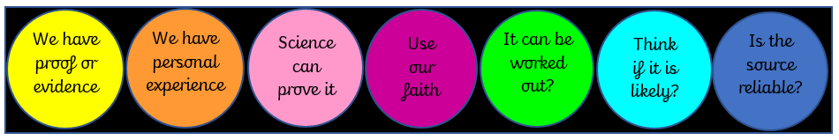  https://www.biblegateway.com/passage/?search=Genesis%201&version=GNT . https://www.biblegateway.com/passage/?search=Genesis+3&version=ICB  Matthew 6:9-13 Explained | Free Resource Guide  Islam  To know why the Qur’an is important to Muslims.  - Recap of holy books from different religions. Children complete task _ who can we go to for guidance? What rules should we follow?  - Spider diagram for Prophet Mohammed  - Write a set of instructions that explain how to show respect to the Qu’ran  - Mind map to explain the night of Power  https://www.bbc.co.uk/bitesize/clips/zf9k2hv  https://www.bbc.co.uk/programmes/p0110cm4  https://www.bbc.co.uk/teach/class-clips-video/religious-education-ks2-my-life-my-religion-the-quran/z4p8mfr  https://www.bbc.co.uk/bitesize/topics/zpdtsbk/articles/zjc2bdm  Bing Videos |  |  |  |  |  | Hinduism  To know about the Hindu Dharma.  - Analyse Tyger, Tyger poem and highlight the truths  - Read a selection of Krishna stories and children decide the moral and guidance  - Story cards to understand the story of Prahlad and then answer questions  - Mind map explaining what they know about Holi  - Create a cartoon short story that has a message.  https://parenting.firstcry.com/articles/top-15-childhood-krishna-stories-kids/  https://www.youtube.com/watch?v=3si_OQBwSEc  What is the festival of Holi? - BBC Bitesize  Christianity - Jesus  To know about the miracles of Jesus.  - Watch 3 videos of modern ‘miracles’ and write why people think they were miracles. Write short paragraph what they think a miracle is  - Read about some of Jesus’ miracles from the bible then complete the retrieval task: colour 5  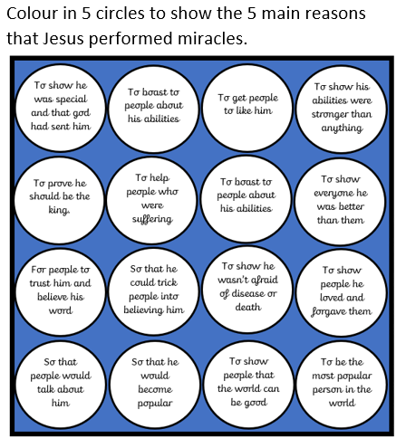  - Spider diagram to explain why Christians see Jesus miracles as a sign of him being devine.  - Look at a range of short poems linked to the power of prayer and believing in miracles, before children write their own.  - Create a poster to explain why people go on pilgrimages.  - Circle time activity with word cards to prompt discussion.  https://www.youtube.com/watch?v=NZEFpTuK6Ks  Teen saves dad's life, lifts truck to free him trapped beneath - YouTube  Man falls 47 Stories and lives to tell about it. (youtube.com)  Sully Sullenberger's Miracle on the Hudson (youtube.com) |  |  |  |  | Christianity - Church  To understand the beliefs of Christians.  - Highlight the apostles creed together and split the articles into 3 main themes to analyse.  - Hexagon retrieval task making links between Christian symbols.  - Design a symbol to represent the trinity  - Spider diagram to explain Christian beliefs  - Venn diagram to show similarities and differences in 3 strands of the Christian faith.  - Discussion session- children write a question on a slip of paper then decide where or who they may find the answer from.  Look at different communities such as Taizé - Google Search  https://www.youtube.com/watch?v=lhiJ4DmqMM8  christian community preston lancashire service - Google Search  Judaism  To know about the importance of the Torah and the Synagogue in the Jewish faith.  - Discussion based on the need for laws then fill in table thinking about need and consequence then think of 2 rules of their own.  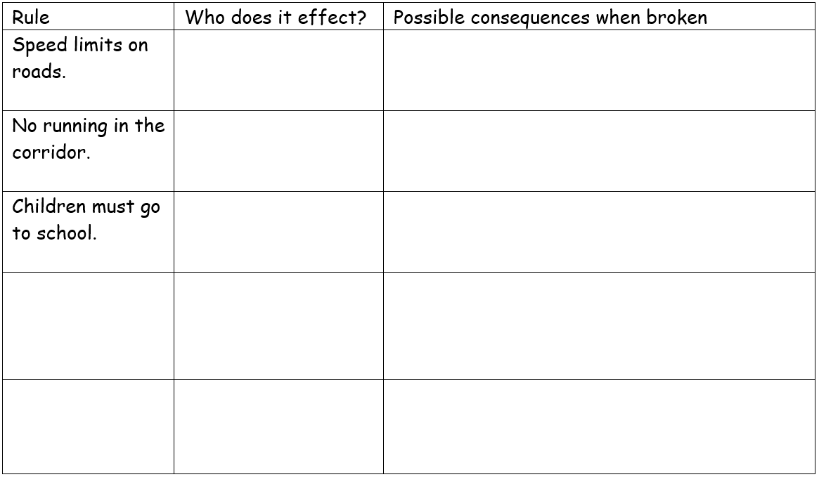  - Mind map about the Torah  - Share 3 stories then the children complete 3 heads retrieval task  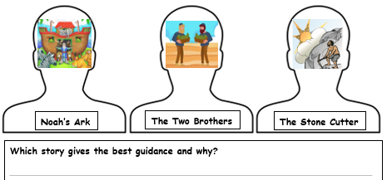  - Write a letter to a Jewish child explaining all you have learnt about Simchat Torah, then ask some questions that you would like to know the answer to  - Poster explaining how some Jewish beliefs could support their own beliefs.  All About Simchat Torah (youtube.com)  Simchat Torah: The Joy of the Torah (youtube.com)  Simchat Torah - Jewish Holidays for Kids! - YouTube  https://www.bbc.co.uk/teach/class-clips-video/what-is-the-torah/zhs2t39
Year Six
Christianity/Hinduism |  |  |  |  | Islam/Christianity |  |  |  |  |  |  |  |  |  | Buddhism/Christianity
- To know how Christians mark the ‘turning points’ on the journey of life.  - To know about the Hindu Dharma journey. |  |  |  |  | - To understand why Hajj is important to Muslims.  - To know why Christians beliefs about the Holy week. |  |  |  |  |  |  |  |  |  | - To know about the Buddha, The four Noble Truths and the Eightfold Path of Buddhism.  - To understand why forgiveness is important to Christians.
Key vocabulary
Christianity – Church  Baptism  Confirmation  Ritual  Relationship  God  Sin  Infant baptism  Believer’s baptism  Commitment |  |  | Hinduism  Karma  Samsara  Moksha  Ashramas  Samskaras |  | Islam  Five pillars  Ummah  Hajj  Ka’ba |  |  |  | Christianity – Jesus  Death  Suffering  Eucharist  Easter symbols  Good Friday  Holy Week  Symbolise  Communion |  |  |  |  |  | Buddhism  Prince Siddhartha  Four Noble Truths  Eightfold Path  Meditation  Nirvana  Suffering |  |  | Christianity – God  Life after death  Death  Resurrection  Heaven  Forgiveness  Confession  Sin  Reconciliation
Suggested tasks and clips
Christianity – Church  - Achievements already made through life  - Match key words linked to baptism and confirmation  - How Christian rituals reflect their relationship with God and explain why it is important to be baptised  - Differences between an infant’s baptism and a believers baptism  - Explain why confirmation is an important sign of commitment  - https://request.org.uk/resource/restart/2014/04/08/infant-baptism-in-an-anglican-church/  - https://request.org.uk/resource/restart/2014/04/08/confirmation/  - https://www.youtube.com/watch?v=9_dr9njVzKM  - https://request.org.uk/resource/life/rites-of-passage/believers-baptism/  - https://request.org.uk/resource/restart/2014/04/08/confirmation/ |  |  | Hinduism  - Discuss milestones we go through within life  - Understand what Hindus believe about Samsara  - Understand the beliefs about karma – make a game of snakes and ladder with positive and negative actions  - Use a spider diagram to explain the four ashramas  - Know and order the 16 samskaras  - https://www.bbc.co.uk/teach/class-clips-video/religious-studies-ks2-my-life-my-religion-hinduism-cycle-of-birth-and-rebirth/zn68qp3  - https://www.youtube.com/watch?v=iXtK40EgJb4  - https://www.youtube.com/watch?v=1mhw7WQ0zxk  - https://www.youtube.com/watch?v=1mhw7WQ0zxk |  | Islam  - Events that have happened in our lives and changed us and to identify their proud moments  - To recap on the the five pillars of Islam (from year 4) and recount them all  - To explore why the Ummah is so important to Muslims around the world  - Why is Hajj so important to Muslims? Write a diary entry of experiences, emotions and reflections of someone who has completed Hajj  - Virtual Hajj around school  - https://www.bbc.co.uk/teach/school-radio/assemblies-five-pillars-of-islam/zvvvp4j  - https://www.natre.org.uk/uploads/Course%20and%20Event%20Flyers/Strictly%20RE%202018/Seminar%20B/ummah.pdf  - https://www.bbc.com/bitesize/clips/z9vcd2p  - https://www.bbc.co.uk/programmes/p02mwk0y |  |  |  | Christianity – Jesus  - Define terms linked to maturing and becoming stronger  - Retell the events leading up to the death of Jesus – easter wheel  - Answer questions based on what the Eucharist is  - Understand what symbols might be associated with Easter and why  - Why do Christians believe Good Friday is good?  - https://www.youtube.com/watch?v=-M8Yesnt1V8  - https://www.bbc.co.uk/teach/class-clips-video/religious-studies-ks2-holy-communion/z7xhy9q  - https://www.youtube.com/watch?v=o2oFHil1uGo  - https://www.christianity.com/wiki/holidays/what-s-so-good-about-good-friday.html |  |  |  |  |  | Buddhism  - Think about the ingredients needed for a happy life  - Write a diary entry as Prince Siddhartha of the Buddhist beliefs and values contained within his story  - Identify and explain The Four Noble Truths – link these to everyday life  - Identify and explain the aspects of The Eightfold Path  - Understand why it is important for Buddha’s to mediate  - https://www.youtube.com/watch?v=9_s-OrWz_Z8  - https://www.bbc.co.uk/programmes/p010xtz3  - https://www.youtube.com/watch?v=TK-MbNj83NM  - https://www.bbc.co.uk/teach/why-do-buddhists-meditate/zdt9f4j |  |  | Christianity – God  - Think about the purpose of human life and what they see themselves doing in their life  - Why Jesus died and reflect on how people believe in life after death  - Research key terms linked to the forgiveness of sin  - Understand what is involved within the 4 steps of reconciliation  - How Christian teachings of forgiveness can be put into practice and chn to give an example  - https://request.org.uk/resource/issues/ultimate-questions/big-questions-why-should-i-forgive/  - https://request.org.uk/resource/life/beliefs/christianity-basically-the-resurrection/  - Kids Explain the Sacrament of Reconciliation - YouTube  - The Four Steps - Reconciliation Education (weebly.com)  - https://www.bbc.co.uk/bitesize/guides/z2b36yc/revision/8

