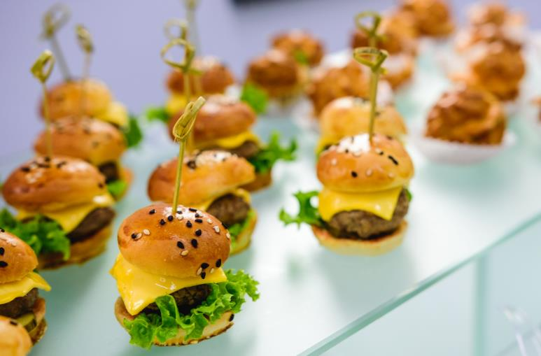
Fun Fact
Watermelons float in water due to their high level content.
What should I already know?
- The names for a variety of foods
- Know why we should have a healthy diet
- Know where some foods come from
- Perform simple foods
- Sort foods into groups (foods from plants and animals)

Key Vocabulary
Hygiene | Keep the body clean and healthy
Carbohydrates | A food that gives the body a fast burst of energy
Dairy | Products made from milk (cheese, yogurt etc)
Protein | Foods that help our body grow stay strong and repair
Chopping | Cutting things into pieces
Cutting | Using equipment to cut things into smaller pieces
Fruit | Something with seeds (banana, apple, orange etc)
Vegetables | Comes from the stem, roots, leaves or flowers of a plant (carrots, broccoli, cabbage etc)
Starchy foods | Foods that help us think, play, run and keep us going.

Key Skills I will learn
- Name party foods and group foods accordingly
- How to prepare food
- Develop knowledge further about where food comes from
- Understand that foods need to be modified for dietary requirements
- Prepare foods hygienically and safely
- Plan, make and evaluate a party food

National Curriculum
- use the basic principles of a healthy and varied diet to prepare dishes
- understand where food comes from



