Fun Fact
Up to 50 books can be made from the pulp of one tree.
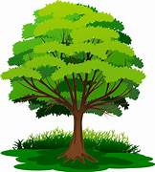

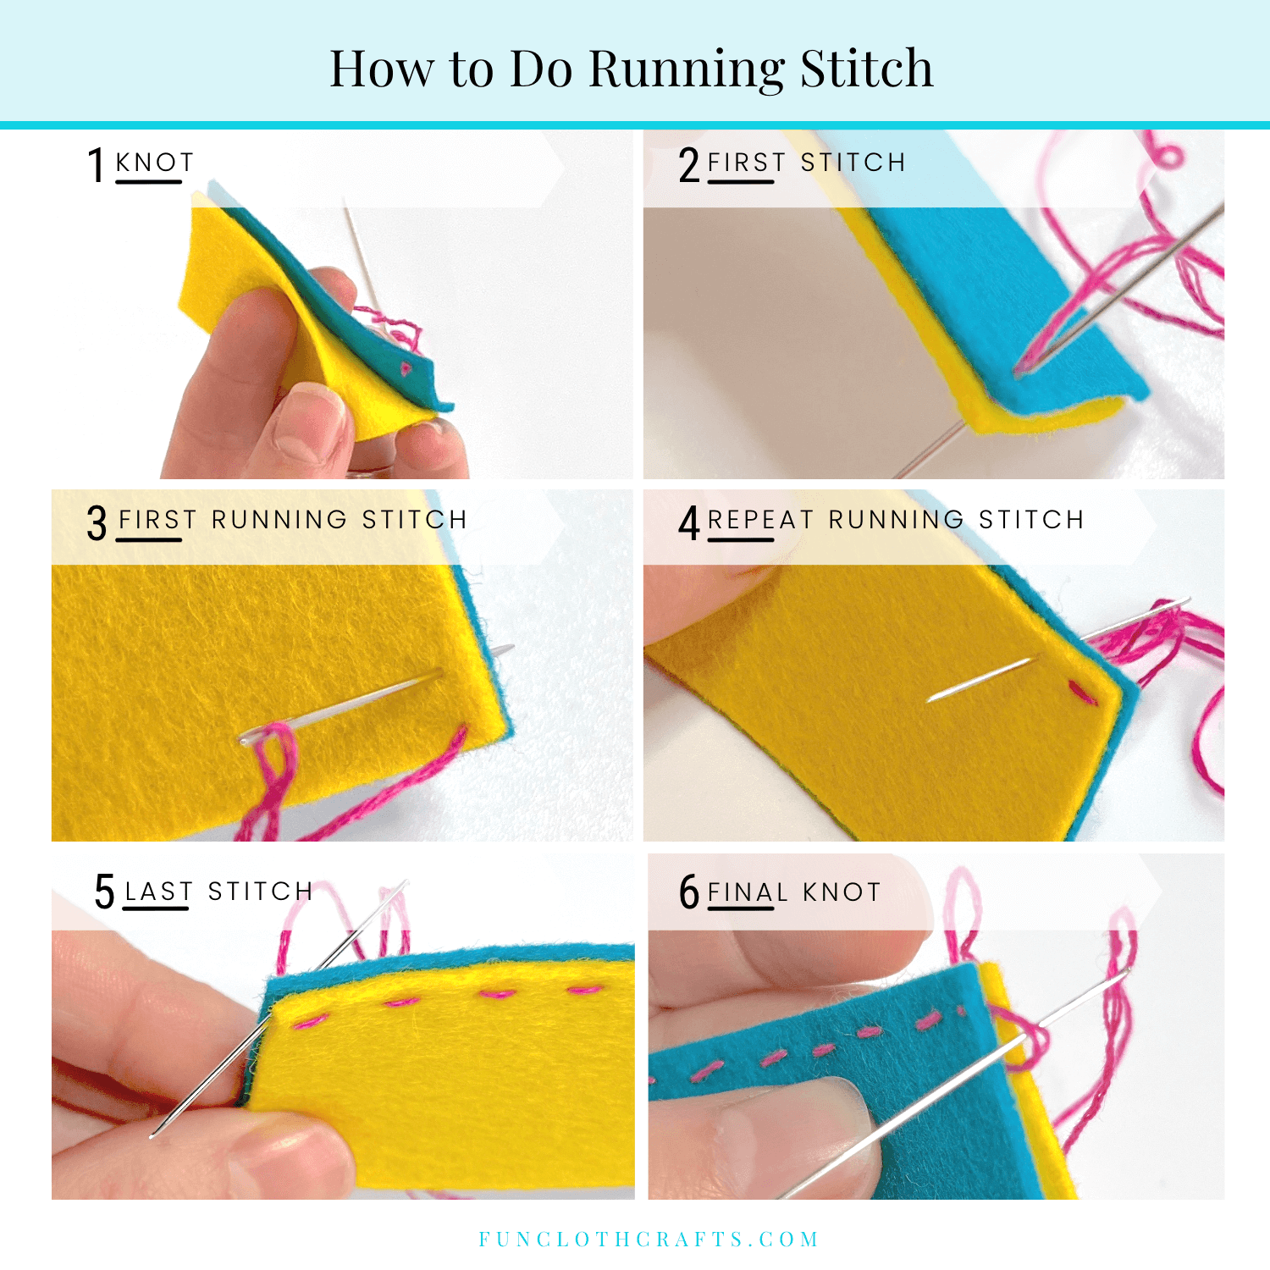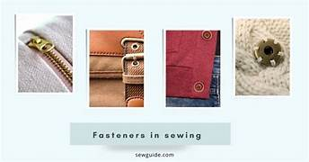
What should I already know?
- A template can be used in the design and make process.
- Two pieces of fabric sewn together makes a seam.
- To thread a needle with cotton
- A book sleeve is a protective cover for a book to prevent it getting damaged.

Key Vocabulary
Fabric | A natural or man-made woven or knitted material that is made from plant fibres, animal fur or synthetic material
Fastening | Something that holds two pieces of material together securely or shuts something, such as buttons, zips and press-studs.
Fix | To repair something.
Needle | A thin, pointed metal object with a small hole at one end for thread which is used in sewing.
Needle Eye | The hole at the top of a needle in which the thread slides through
Thread | A length of a very thin fibre.
Template | A stencil you use to draw the same shape more easily on a different fabric.
Running stitch | A simple style of sewing in a straight line with no overlapping.
Evaluation | When you look at the good and bad points of something, then think of how you could improve it.

Key Skills I will learn
- What the main types of fastenings are.
- To write a design criteria.
- To design a product (book cover) based on a design criteria.
- To make and test a paper template.
- To join fabric by sewing.
- To evaluate my product.



