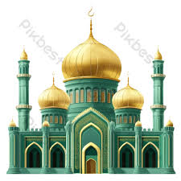
Key Skills I will learn
- identify that Islamic beliefs about God motivate most Muslims to pray on a regular basis
- describe the rituals of Islamic prayer (salah), including wudhu and use of a prayer mat
- suggest how making time for the five daily prayers is an act of submission
- talk about the ways in which shared rituals might unite communities
- talk about the things they do on a regular basis as a sign of their commitment and belonging
- suggest why Muslims believe that it is important to respect God
- talk about why Muslims would want to show their gratitude to God

What should I already know?
- know that Muslims believe in one God (Allah)
- know that Muslims believe the world was created by God
- know that Islam teaches that humans should take care of the planet
- Suggest how Muslims might show respect for God by caring for the natural world

Fun Fact
It is the fastest growing religion
Key Vocabulary
Allah | God
Quran | The holy book of Islam
Muslim | A person who follows the religion of Islam
Salah | Daily prayer, often performed five times a day
Wudu | Ritual washing before prayer
Prophet Muhammed | The final messenger of Allah
Mosque | Place of worship




