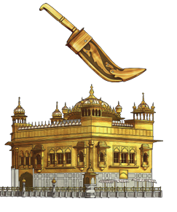
What should I already know?
- Know that religion is about beliefs, practices, and ways of life
- Recognise that people belong to different religions (e.g. Christianity, Islam, Hinduism, Sikhism)
- Show awareness that people live differently based on beliefs
- Demonstrate respect for different religions and worldviews
- Begin to compare similarities and differences between religions

Key Skills I will learn
- Retell and suggest meanings for religious stories, actions and symbols.
- Use religious words and phrases and consistently identify some features of religious traditions.
- Begin to identify and describe how religion is expressed in different ways.
- Talk about what is of value and concern to themselves and to others.
- Talk about what they find interesting or puzzling.
- To ask important questions about religions and belief.
Fun Fact
Sikhism is the fifth-largest religion in the world
Key Vocabulary
Sikhism | One of the world’s main religions.
Sikh | Someone who follows Sikhism.
Guru | Spiritual teacher.
Guru Nanak | The founder of Sikhism.
Gurdwara | A Sikh place of worship.
Guru Granth Sahib | The Sikh holy text.
Sargun | The belief that God is everywhere and in everything.



