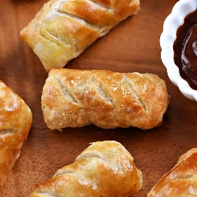
Fun Fact
Samosas originated in the Middle East, not India, known as "sambosa" and appearing around the 10th century as a meat-filled snack for travelers.
What should I already know?
- The amount of foods that come from each part of the Eatwell Guide
- The two largest food groups
- Steps to get ready to cook
- The equipment used for different food preparation tasks

Key Vocabulary
Hygiene | Keep the body clean and healthy
On-the-go | When travelling or out of the house, busy
Healthy | In a good physical condition
Peeling | Remove the outer covering or skin from (a fruit or vegetable)
Grating | Reducing food into small shreds by rubbing it against a rough, perforated surface
Cutting | Removing a part of something, reducing quantities
Recipe | A set of instructions for preparing a particular dish, including a list of the ingredients required
Nutrients | A substance that provides nourishment essential for the maintenance of life and for growth.

Key Skills I will learn
- give examples of on-the-go products and discuss their characteristics.
- name a selection of nutrients, their functions in the body and foods that provide the nutrients.
- recall that we can get the nutrients we need by having a healthy, varied diet, as shown by the Eatwell Guide.
- read and interpret nutrition information labels.
- use guidelines to identify foods that are high or low in fat, salt and sugars.
- analyse a selection of products and express their opinions about ingredients using sensory vocabulary.
- demonstrate that they know the getting ready to cook steps.
- explain the role of the getting ready to cook steps in ensuring food is hygienically prepared and safe to eat.
- perform food skills safely and as instructed to make a spring roll (e.g. peel, grate, cut using the bridge hold and fork secure/claw grip).
- write a list of design criteria for an on-the-go product.
- design an on-the-go product based on the design criteria.
- write a recipe to make an on-the-go product.
- make their on-the-go product according to the plan.
- evaluate their on-the-go product against the design criteria.
National Curriculum
- understand and apply the principles of a healthy and varied diet
- prepare and cook a variety of predominantly savoury dishes using a range of cooking techniques
- understand seasonality and know where and how a variety of ingredients are grown, reared, caught and processed.



