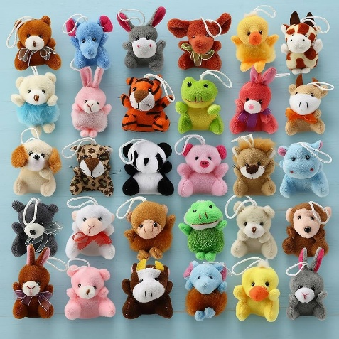
What should I already know?
- The main types of fastenings are.
- The benefits of each fastening type are.
- The disadvantages of each fastening type are.
- To design a product based on a design criteria.
- To write a design criteria.
- To join fabric by sewing.
- To stick to my design criteria.
Fun Fact
Stuffed toys were designed for comfort and therapeutic emotional regulation, even reducing pain in children.

Key Vocabulary
Appendage | A thing that is added or attached to something larger or more important.
Blanket-stitch | A stitch used to reinforce the edge of thick materials
Fabric | Cloth or other materials produced by weaving or knitting fibres
Sew | Join, fasten, or repair (something) by making stitches with a needle and thread
Stuffed toy | A toy with an outer fabric sewn from a textile and stuffed with flexible material
Stuffing | Padding used to stuff cushions, furniture, or soft toys
Template | A shaped piece of rigid material used as a pattern for processes such as cutting out
Evaluation | Concerned with determining the quality and effectiveness of a programme, project or practice

Key Skills I will learn
- Designing a stuffed toy considering the main component shapes required and creating an appropriate template.
- Considering the proportions of individual components.
- Creating a 3D stuffed toy from a 2D design.
- Measuring, marking and cutting fabric accurately and independently.
- Creating strong and secure blanket stitches when joining fabric.
- Threading needles independently. Using appliqué to attach pieces of fabric decoration.
- Sewing blanket stitch to join fabric.
- Applying blanket stitch so the spaces between the stitches are even and regular.
- Testing and evaluating an end product and giving points for further improvements.

National Curriculum
- generate, develop, model and communicate their ideas through discussion, annotated sketches, cross-sectional and exploded diagrams, prototypes, pattern pieces and computer-aided design
- select from and use a wider range of tools and equipment to perform practical tasks [for example, cutting, shaping, joining and finishing], accurately
- select from and use a wider range of materials and components, including construction materials, textiles and ingredients, according to their functional properties and aesthetic qualities
- investigate and analyse a range of existing products
- evaluate their ideas and products against their own design criteria and consider the views of others to improve their work



