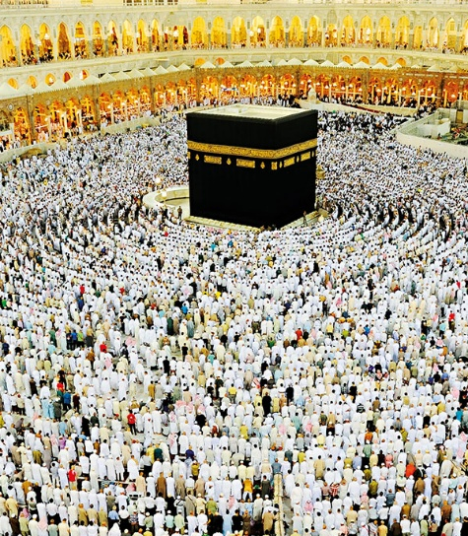
What should I already know?
- Who Prophet Mohammed is
- How to respect the Qu’ran
- Why the Qu’ran is important to Muslims
- What is meant by tht night of power
Fun Fact
When Muslims pray, they must always face Makkah in Saudi Arabia.
Key Vocabulary
The five pillars | The core practices and duties that guide a Muslim’s life, forming the foundation of their faith
Ummah | The global community of Muslims
Hajj | The annual pilgrimage to Mecca, Saudi Arabia, which all physically and financially able Muslims must perform at least once in their lifetime.
Ka’ba | A very important building for Islam. It stands in the middle of the Al-Masjid Al-Ḥarām (The Sacred Mosque) in Makkah, Saudi Arabia

Key Skills I will learn
- analyse the Five Pillars of Islam and how they are linked
- explain how the beliefs and values of Islam might guide a person through life
- explain the importance of the Ummah for Muslims and that this is a community of diverse members
- describe and explain the importance of Hajj, including the practices, rituals and impact
- explain how a person might change once becoming a hajji consider how important it is for a Muslim to go on hajj – and what this means for those who are unable to make the pilgrimage


