What should I already know?
- About Tyger and the truths within the poem
- Moral and guidance from Krishna
- The story of Prahlad
- What Holi is
Fun Fact
Hinduism is over 4,000 years old, making it one of the world's oldest religions.
Key Vocabulary
Karma | An action or deed and is the universal law of cause and effect.
Samsara | The continuous, repeating cycle of birth, life, death, and rebirth
Moksha | Representing liberation or release from the cycle of birth, death, and rebirth (Samsara)
Ashrama | The four stages of life, each with specific duties (dharma) that a person is expected to follow to live a balanced life
Samskara | Samskaras (or Sanskars) are sacred rites of passage or rituals that mark important stages in a person's life, from before birth to after death
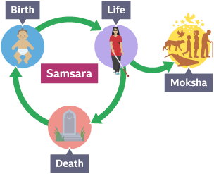

Key Skills I will learn
- analyse Hindu beliefs about samsara, karma and moksha and how these are linked
- explain how belief in reincarnation might affect the way in which a Hindu views the ‘journey of life’
- explain how belief in reincarnation and the law of karma might affect the way a Hindu lives
- describe and explain the four ashramas (stages of life) in the life of a Hindu
- explain how a person might change as they move from one ashrama to the next
- consider the importance of the samskaras (rites of passage) in preparing a Hindu for the commitments of each ashrama



