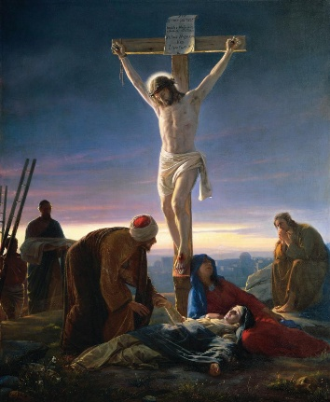
Fun Fact
Christians believe Jesus is the Son of God and the Messiah promised in the Old Testament, sent to save people from their sins.
What should I already know?
- The miracles of Jesus
- Why miracles are a sign of him being divine
- Power of prayer
- Why people go on pilgrimages
Key Vocabulary
Death | The permanent end of a living thing’s physical life, where the body stops working
Suffering | Pain, distress, or misery—whether physical, emotional, or mental—experienced by people
Eucharist | A central Christian service, also known as Holy Communion or Mass, where believers remember Jesus’ Last Supper
Good Friday | A day that commemorates the crucifixion and death of Jesus Christ
Communion | A central Christian ritual where believers share bread and wine to remember the Last Supper
Symbolise | To represent, stand for, or identify something else using a character, image, or sign

Key Skills I will learn
- retell the events leading up to and including the death of Jesus
- explain how beliefs about the suffering, death and resurrection of Jesus might guide and comfort a Christian during difficult times in their own life
- explain how and why Christian individuals and communities might celebrate the events of Holy Week
- use religious vocabulary to describe and explain the Eucharist
- explain different Christian beliefs about the Eucharist and its importance



