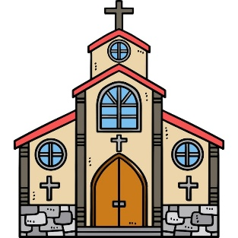
What should I already know?
- The beliefs of Christians.
- About the apostle’s creed
- What the trinity represents
- The 3 strands of the Christian faith.
Fun Fact
Pulpit’s found in churches are raised stands which Christian clergy will climb up into, to speak and preach to the congregation.
Key Vocabulary
Baptism | A special Christian ceremony marking a person's entry into the Church and "God’s family"
Confirmation | A Christian ceremony where a baptized person publicly confirms the promises made on their behalf as a baby
Ritual | Similar to a ceremony. It is a series of things is done in a special order
Sin | A thought, word, or action that goes against God's law or misses the mark of loving God and others
Infant Baptism | Christian ceremony where water is poured or sprinkled on a baby to welcome them into the church family, wash away original sin, and bless them in God's name
Believers Baptism | A Christian ceremony for teenagers or adults who choose for themselves to follow Jesus, rather than being baptized as babies.
Relationship | The connection, bond, or way in which two or more people are linked, behave towards, and interact with each other

Key Skills I will learn
- Explain how rituals (sacraments/rites of passage) might reflect Christian beliefs about their relationship with God
- Explain how these rituals might differ between different denominations (eg. infant baptism and believer’s baptism)
- Analyse the importance of Christian rites of passage as an expression of faith and commitment
- *Use religious vocabulary to explain the symbolism of words and actions used within rituals and ceremonies



