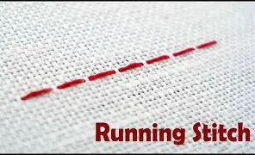
What should I already know?
- Name a variety of materials used in making things
- How to glue and add fabrics together
- How to decorate a piece of fabric
- How to do a simple stitch

Fun Fact
Sewing has been used for over 30,000 years. Early humans made needles from bones.
Key Vocabulary
Thread | A long, thin strand of fibers twisted together.
Running stitch | A technique in sewing that is in a straight line
Fabric | A material used for making things
Textiles | Products made from woven fibers
Template | A guide or pattern used to cut and trace a design
Sewing | A skill used to make or repair something with stitching
Decorate | Add extra detail to make it look more attractive
Key Skills I will learn
- To use a running stitch with regular-sized stitches and understand that both ends must be knotted.
- Prepare and cut fabric to make a pouch from a template.
- Use a running stitch to join the two pieces of fabric together.
- Decorate a pouch using the materials provided.
National Curriculum
- design purposeful, functional, appealing products for themselves and other users based on design criteria
- select from and use a wide range of materials and components, including construction materials, textiles and ingredients, according to their characteristics


