Year Four – Summer 2nd term
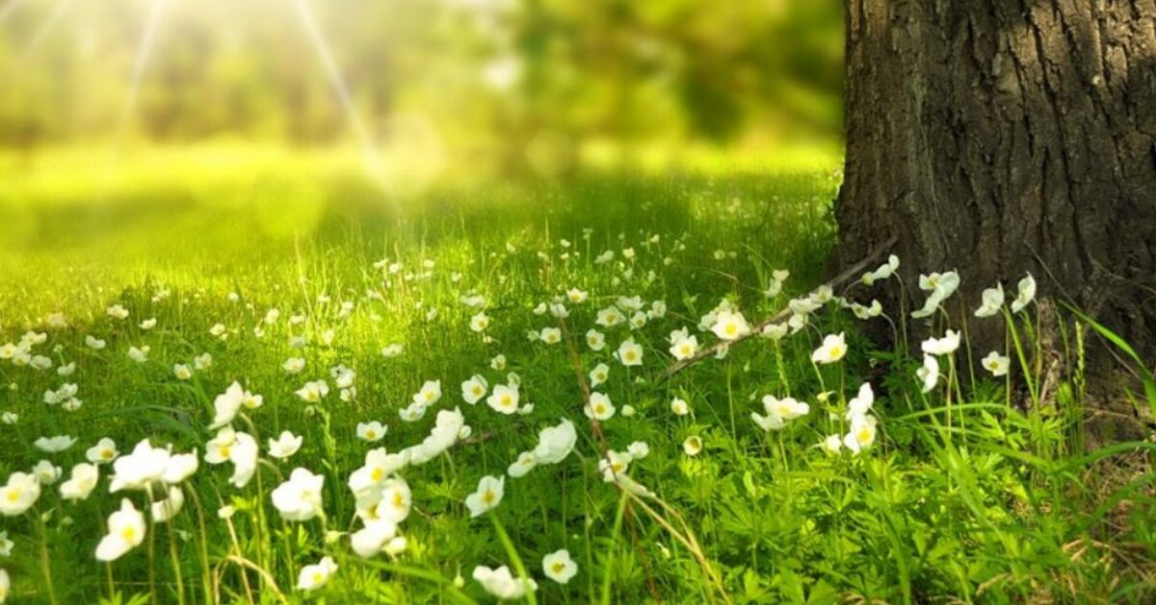

A warm welcome back to school for all the Year 4 pupils for our final half term!
English (reading and writing)
In English, the pupils will be exploring fairy tales and their main features. They will then plan and write their own fairy tales. In the non-fiction focus, will be looking at information texts in order to write their own information booklets. They will explore different texts to stimulate interest and explore new and related vocabulary. Spelling, punctuation and grammar rules will be covered daily to ensure pupils are developing their Literacy skills.
Maths
Maths will focus on; place value and number including fractions, negative numbers, Roman Numerals and the properties of shapes. Pupils will continue to learn times tables and related division facts up to x12.
Please note that Year 4 will be sitting a national times tables test this half term. Therefore, it is extremely important that pupils continue to learn the multiplication facts up to x12.
Further curriculum subjects & Topic
- In Science, pupils will continue to learn about the changing states of matter including the Water Cycle.
- The Geography topic this term involves pupils in learning about the River Nile and the River Ribble. They will learn about the key parts of a river and compare both rivers and undertake research to investigate how they are utilised.
- The RE topic is Christianity,the focus this half term is on the church and what it means to Christians.
- Our new ICT topic is ‘Programming – repetition in games’.
- Pupils will continue to learn about their health and wellbeing with a focus on mental health.
Class reminders
P.E is on a Tuesday and Thursday. Please ensure that your child wears their PE kit on those days.
Homework and spellings will be handed out on Fridays and expected to be in school by the following Thursday.
Home reading is encouraged every night.

