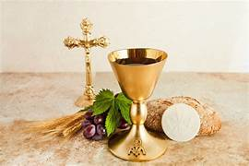
What should I already know?
The cross is the sign of Christianity, God is the creator, Christians pray in a church. The Bible is the holy book and is split into two sections. Christians celebrate the day Jesus was born, this is Christmas and when he died at Easter. Jesus is the son of God.

Key Vocabulary

font | A special basin that holds holy water for Baptisms.
Lectern | A stand where the Bible is read from.
Pulpit | A raised platform where the priest or reverend can talk to the people from.
Alter | A special table that holds the bread and wine.
Holy Eucharist | A sacrament accepted by most Christians that attend church.
Pews | The seating area for the congregation.
Congregation | The people who visit church for mass.

. 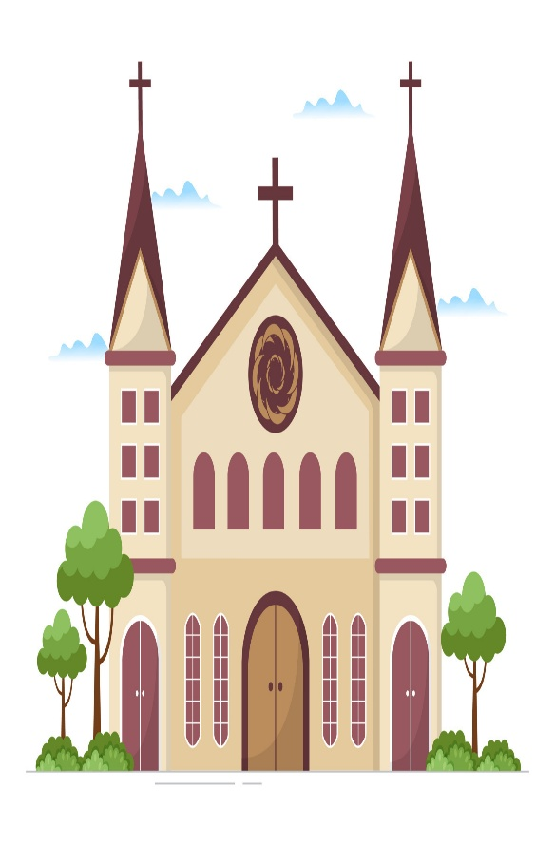
Key Skills I will learn
- Use specific vocabulary to describe churches and living traditions.
- Begin to identify the impact that religion has on believers’ lives.
- Make links between believers’ values and commitments and their own.
- Ask important questions about religion and beliefs and compare to their own experiences.

