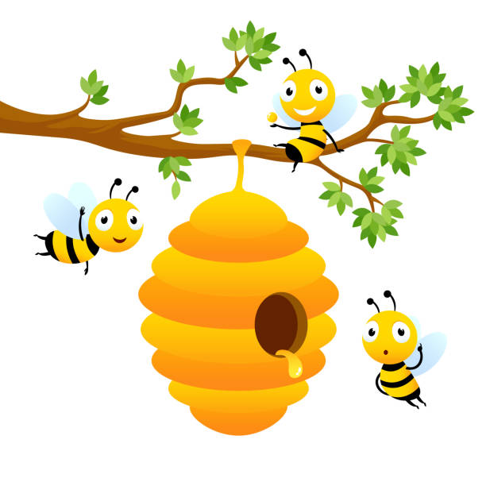
Welcome to
The Beehive

Our busy, beautiful Beehive is a calm, loving and nurturing environment for our children to learn and play.

It has been created especially for children who we believe would benefit from time in a smaller classroom environment with greater adult support.

The Beehive is a space we are proud of and our dedicated staff make it an area that is loved by the children.

Learning in the Beehive is based around a theme and follows the continuous provision approach of the EYFS.

We work closely with outside agencies to provide support for our children to develop academically, socially and emotionally through activities linked to, but not limited to, speaking and listening, fine motor skills, gross motor skills, number recognition and letter recognition.

In the afternoons our children go back into class where they are supported whilst they learn with their peers.

The Beehive
The Beehive has been created to provide a learning space for our children with the most pressing Special Educational Needs. As such, all the children have an EHCP or we are in the process of gathering evidence to obtain one.
The Beehive is designed to be a short-term placement for children who we feel are not ready for the structured setting of a formal classroom or who are unable to access the National Curriculum at an age-appropriate level.
Consequently, the children will learn through activities which have been carefully tailored to meet EHCP targets or which have been agreed with outside agencies.
It is important to stress that The Beehive is not a specialist SEND unit but rather a classroom and an outdoor space in which the children can be taught as part of a small group or on a 1-1 basis.
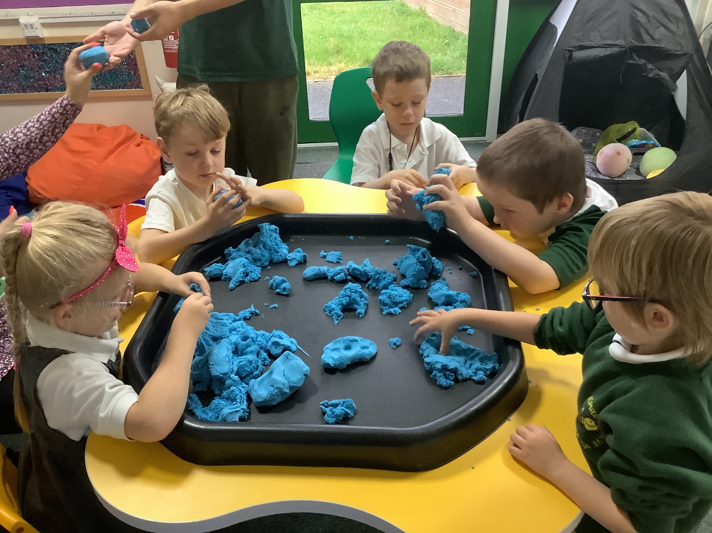

Environment
We endeavour to have no more than 7 children accessing The Beehive at any one time. With up to three members of staff, this will give us a ratio of no more than just over 2:1.
The classroom is carefully resourced and designed to be similar in nature to a Reception classroom with a continuous provision approach.
The outdoor area is used to support learning as well as developing play and social skills.
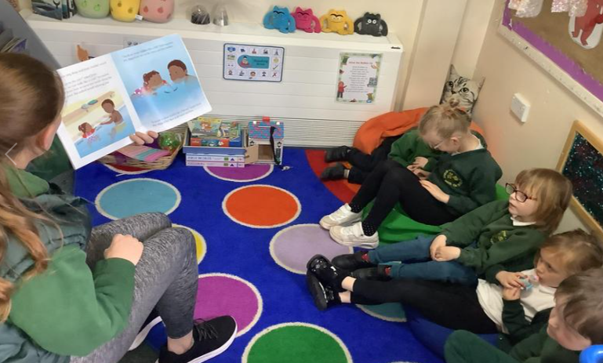

Responsibilities
The Head and SENCO have overall responsibility for The Beehive. They will use a combination of data and professional judgement to decide which children will access The Beehive.
The SENCO meets weekly with the HLTA to discuss the progress of individual children within The Beehive, to review targets and to agree on any necessary action.
The SENCO keeps the Head updated weekly through SLT meetings and informs her immediately of any pressing matters.
The HLTA assumes responsibility for resourcing and shares this with her colleagues. Planning overviews are agreed with the SLT and linked to topics in the classroom where possible.
As part of the professional development of staff in The Beehive, all staff will have the opportunity to lead small group sessions.
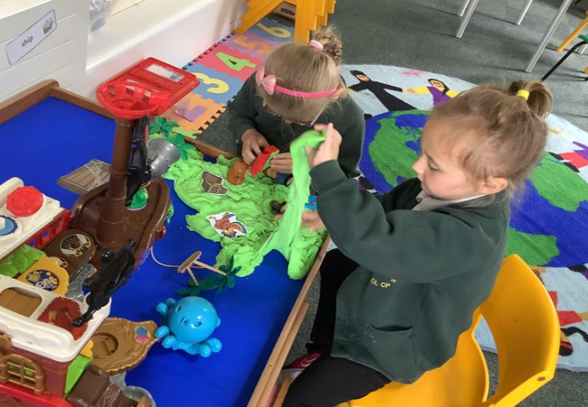
Staff will be allocated children over the course of the morning for which they will assume personal responsibility in terms of changing nappies, selecting dinner choices etc.

Assessment
In The Beehive we follow the graduated approach of Assess, Plan, Do, Review. As such, all the children are in receipt of an individual support plan which is linked to their EHCP targets, guided by professional external agencies and informed by ongoing formative and summative assessments.
These targets are broken down into short, manageable SMART targets which are progressive in nature and assessed daily in order that support plans can be updated accordingly.
Support plans and assessments are shared with class teachers and external agencies and are used as evidence to inform future provision.


